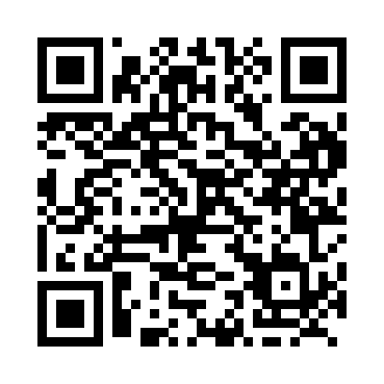
Prayer times for Tonkin, Saskatchewan, Canada
Wed 1 May 2024 - Fri 31 May 2024
High Latitude Method: Angle Based Rule
Prayer Calculation Method: Islamic Society of North America
Asar Calculation Method: Hanafi

Date | Day | Fajr | Sunrise | Dhuhr | Asr | Maghrib | Isha
1 | Wed | 3:25 | 5:20 | 12:46 | 5:53 | 8:13 | 10:09
2 | Thu | 3:22 | 5:19 | 12:46 | 5:54 | 8:14 | 10:11
3 | Fri | 3:19 | 5:17 | 12:46 | 5:55 | 8:16 | 10:14
4 | Sat | 3:17 | 5:15 | 12:46 | 5:56 | 8:17 | 10:17
5 | Sun | 3:14 | 5:13 | 12:46 | 5:57 | 8:19 | 10:19
6 | Mon | 3:11 | 5:12 | 12:46 | 5:58 | 8:21 | 10:22
7 | Tue | 3:08 | 5:10 | 12:46 | 5:59 | 8:22 | 10:25
8 | Wed | 3:05 | 5:08 | 12:46 | 6:00 | 8:24 | 10:28
9 | Thu | 3:02 | 5:07 | 12:45 | 6:01 | 8:25 | 10:30
10 | Fri | 2:59 | 5:05 | 12:45 | 6:02 | 8:27 | 10:33
11 | Sat | 2:57 | 5:03 | 12:45 | 6:03 | 8:28 | 10:36
12 | Sun | 2:54 | 5:02 | 12:45 | 6:04 | 8:30 | 10:38
13 | Mon | 2:53 | 5:00 | 12:45 | 6:05 | 8:31 | 10:39
14 | Tue | 2:52 | 4:59 | 12:45 | 6:06 | 8:33 | 10:39
15 | Wed | 2:52 | 4:57 | 12:45 | 6:06 | 8:34 | 10:40
16 | Thu | 2:51 | 4:56 | 12:45 | 6:07 | 8:36 | 10:41
17 | Fri | 2:50 | 4:55 | 12:46 | 6:08 | 8:37 | 10:42
18 | Sat | 2:50 | 4:53 | 12:46 | 6:09 | 8:39 | 10:42
19 | Sun | 2:49 | 4:52 | 12:46 | 6:10 | 8:40 | 10:43
20 | Mon | 2:48 | 4:51 | 12:46 | 6:11 | 8:41 | 10:44
21 | Tue | 2:48 | 4:49 | 12:46 | 6:11 | 8:43 | 10:44
22 | Wed | 2:47 | 4:48 | 12:46 | 6:12 | 8:44 | 10:45
23 | Thu | 2:47 | 4:47 | 12:46 | 6:13 | 8:45 | 10:46
24 | Fri | 2:46 | 4:46 | 12:46 | 6:14 | 8:47 | 10:47
25 | Sat | 2:46 | 4:45 | 12:46 | 6:14 | 8:48 | 10:47
26 | Sun | 2:45 | 4:44 | 12:46 | 6:15 | 8:49 | 10:48
27 | Mon | 2:45 | 4:43 | 12:46 | 6:16 | 8:50 | 10:49
28 | Tue | 2:44 | 4:42 | 12:46 | 6:17 | 8:52 | 10:49
29 | Wed | 2:44 | 4:41 | 12:47 | 6:17 | 8:53 | 10:50
30 | Thu | 2:44 | 4:40 | 12:47 | 6:18 | 8:54 | 10:50
31 | Fri | 2:43 | 4:39 | 12:47 | 6:19 | 8:55 | 10:51
Prayer times provided by https://www.salahtimes.com

