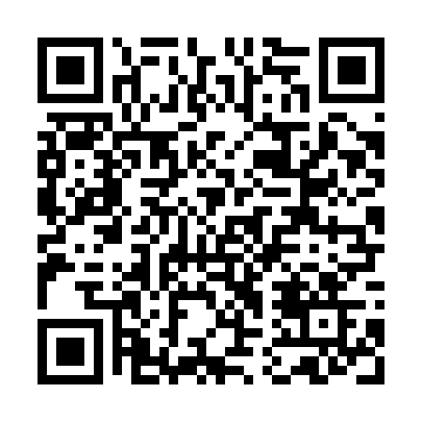

**Prayer times for Montbrun-Bocage, France**

**Sun 1 Sep 2024 - Mon 30 Sep 2024**

**High Latitude Method: Angle Based Rule**

**Prayer Calculation Method: Islamic Organisations Union of France**

**Asar Calculation Method: Shafi**

|  |  |  |  |  |  |  |  |
| --- | --- | --- | --- | --- | --- | --- | --- |
| **Date** | **Day** | **Fajr** | **Sunrise** | **Dhuhr** | **Asr** | **Maghrib** | **Isha** |
| 1 | Sun | 6:15 | 7:20 | 1:55 | 5:36 | 8:29 | 9:33 |
| 2 | Mon | 6:17 | 7:21 | 1:54 | 5:35 | 8:27 | 9:32 |
| 3 | Tue | 6:18 | 7:22 | 1:54 | 5:34 | 8:26 | 9:30 |
| 4 | Wed | 6:19 | 7:23 | 1:54 | 5:33 | 8:24 | 9:28 |
| 5 | Thu | 6:20 | 7:24 | 1:53 | 5:32 | 8:22 | 9:26 |
| 6 | Fri | 6:22 | 7:25 | 1:53 | 5:31 | 8:20 | 9:24 |
| 7 | Sat | 6:23 | 7:26 | 1:53 | 5:30 | 8:19 | 9:22 |
| 8 | Sun | 6:24 | 7:27 | 1:52 | 5:28 | 8:17 | 9:20 |
| 9 | Mon | 6:25 | 7:28 | 1:52 | 5:27 | 8:15 | 9:18 |
| 10 | Tue | 6:27 | 7:29 | 1:52 | 5:26 | 8:13 | 9:16 |
| 11 | Wed | 6:28 | 7:31 | 1:51 | 5:25 | 8:12 | 9:14 |
| 12 | Thu | 6:29 | 7:32 | 1:51 | 5:24 | 8:10 | 9:12 |
| 13 | Fri | 6:30 | 7:33 | 1:51 | 5:23 | 8:08 | 9:10 |
| 14 | Sat | 6:31 | 7:34 | 1:50 | 5:22 | 8:06 | 9:08 |
| 15 | Sun | 6:33 | 7:35 | 1:50 | 5:20 | 8:04 | 9:07 |
| 16 | Mon | 6:34 | 7:36 | 1:50 | 5:19 | 8:02 | 9:05 |
| 17 | Tue | 6:35 | 7:37 | 1:49 | 5:18 | 8:01 | 9:03 |
| 18 | Wed | 6:36 | 7:38 | 1:49 | 5:17 | 7:59 | 9:01 |
| 19 | Thu | 6:37 | 7:39 | 1:49 | 5:15 | 7:57 | 8:59 |
| 20 | Fri | 6:39 | 7:40 | 1:48 | 5:14 | 7:55 | 8:57 |
| 21 | Sat | 6:40 | 7:41 | 1:48 | 5:13 | 7:53 | 8:55 |
| 22 | Sun | 6:41 | 7:43 | 1:47 | 5:12 | 7:52 | 8:53 |
| 23 | Mon | 6:42 | 7:44 | 1:47 | 5:10 | 7:50 | 8:51 |
| 24 | Tue | 6:43 | 7:45 | 1:47 | 5:09 | 7:48 | 8:50 |
| 25 | Wed | 6:44 | 7:46 | 1:46 | 5:08 | 7:46 | 8:48 |
| 26 | Thu | 6:46 | 7:47 | 1:46 | 5:07 | 7:44 | 8:46 |
| 27 | Fri | 6:47 | 7:48 | 1:46 | 5:05 | 7:43 | 8:44 |
| 28 | Sat | 6:48 | 7:49 | 1:45 | 5:04 | 7:41 | 8:42 |
| 29 | Sun | 6:49 | 7:50 | 1:45 | 5:03 | 7:39 | 8:40 |
| 30 | Mon | 6:50 | 7:52 | 1:45 | 5:01 | 7:37 | 8:39 |

**Prayer times provided by https://www.salahtimes.com**