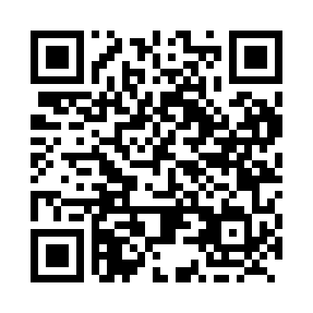

**Prayer times for Laketon, British Columbia, Canada**

**Sun 1 Sep 2024 - Mon 30 Sep 2024**

**High Latitude Method: Angle Based Rule**

**Prayer Calculation Method: Islamic Society of North America**

**Asar Calculation Method: Hanafi**

|  |  |  |  |  |  |  |  |
| --- | --- | --- | --- | --- | --- | --- | --- |
| **Date** | **Day** | **Fajr** | **Sunrise** | **Dhuhr** | **Asr** | **Maghrib** | **Isha** |
| 1 | Sun | 4:32 | 6:40 | 1:40 | 6:19 | 8:39 | 10:47 |
| 2 | Mon | 4:35 | 6:43 | 1:40 | 6:16 | 8:36 | 10:43 |
| 3 | Tue | 4:38 | 6:45 | 1:39 | 6:14 | 8:33 | 10:39 |
| 4 | Wed | 4:42 | 6:47 | 1:39 | 6:12 | 8:30 | 10:35 |
| 5 | Thu | 4:45 | 6:49 | 1:39 | 6:10 | 8:27 | 10:31 |
| 6 | Fri | 4:48 | 6:51 | 1:38 | 6:07 | 8:24 | 10:27 |
| 7 | Sat | 4:51 | 6:54 | 1:38 | 6:05 | 8:21 | 10:23 |
| 8 | Sun | 4:54 | 6:56 | 1:38 | 6:03 | 8:18 | 10:20 |
| 9 | Mon | 4:57 | 6:58 | 1:37 | 6:01 | 8:16 | 10:16 |
| 10 | Tue | 5:00 | 7:00 | 1:37 | 5:58 | 8:13 | 10:12 |
| 11 | Wed | 5:03 | 7:02 | 1:37 | 5:56 | 8:10 | 10:08 |
| 12 | Thu | 5:06 | 7:05 | 1:36 | 5:54 | 8:07 | 10:05 |
| 13 | Fri | 5:09 | 7:07 | 1:36 | 5:51 | 8:04 | 10:01 |
| 14 | Sat | 5:12 | 7:09 | 1:36 | 5:49 | 8:01 | 9:58 |
| 15 | Sun | 5:15 | 7:11 | 1:35 | 5:47 | 7:58 | 9:54 |
| 16 | Mon | 5:17 | 7:13 | 1:35 | 5:44 | 7:55 | 9:51 |
| 17 | Tue | 5:20 | 7:16 | 1:35 | 5:42 | 7:52 | 9:47 |
| 18 | Wed | 5:23 | 7:18 | 1:34 | 5:39 | 7:49 | 9:44 |
| 19 | Thu | 5:26 | 7:20 | 1:34 | 5:37 | 7:46 | 9:41 |
| 20 | Fri | 5:28 | 7:22 | 1:34 | 5:34 | 7:43 | 9:37 |
| 21 | Sat | 5:31 | 7:24 | 1:33 | 5:32 | 7:41 | 9:34 |
| 22 | Sun | 5:34 | 7:27 | 1:33 | 5:30 | 7:38 | 9:31 |
| 23 | Mon | 5:36 | 7:29 | 1:32 | 5:27 | 7:35 | 9:27 |
| 24 | Tue | 5:39 | 7:31 | 1:32 | 5:25 | 7:32 | 9:24 |
| 25 | Wed | 5:41 | 7:33 | 1:32 | 5:22 | 7:29 | 9:21 |
| 26 | Thu | 5:44 | 7:36 | 1:31 | 5:20 | 7:26 | 9:18 |
| 27 | Fri | 5:46 | 7:38 | 1:31 | 5:17 | 7:23 | 9:14 |
| 28 | Sat | 5:49 | 7:40 | 1:31 | 5:15 | 7:20 | 9:11 |
| 29 | Sun | 5:51 | 7:42 | 1:30 | 5:12 | 7:17 | 9:08 |
| 30 | Mon | 5:54 | 7:44 | 1:30 | 5:10 | 7:14 | 9:05 |

**Prayer times provided by https://www.salahtimes.com**