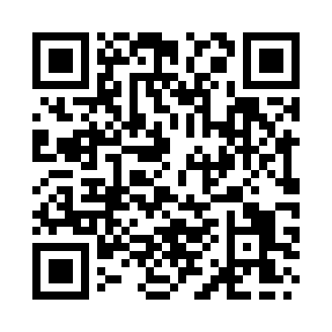

**Prayer times for East Ness, North Yorkshire, UK**

**Sun 1 Sep 2024 - Mon 30 Sep 2024**

**High Latitude Method: Angle Based Rule**

**Prayer Calculation Method: Islamic Society of North America**

**Asar Calculation Method: Hanafi**

|  |  |  |  |  |  |  |  |
| --- | --- | --- | --- | --- | --- | --- | --- |
| **Date** | **Day** | **Fajr** | **Sunrise** | **Dhuhr** | **Asr** | **Maghrib** | **Isha** |
| 1 | Sun | 3:39 | 6:00 | 1:05 | 5:44 | 8:09 | 10:29 |
| 2 | Mon | 3:43 | 6:02 | 1:05 | 5:42 | 8:06 | 10:24 |
| 3 | Tue | 3:47 | 6:05 | 1:05 | 5:39 | 8:03 | 10:19 |
| 4 | Wed | 3:51 | 6:07 | 1:04 | 5:37 | 8:00 | 10:15 |
| 5 | Thu | 3:55 | 6:10 | 1:04 | 5:35 | 7:57 | 10:11 |
| 6 | Fri | 3:59 | 6:12 | 1:04 | 5:32 | 7:54 | 10:06 |
| 7 | Sat | 4:02 | 6:14 | 1:03 | 5:30 | 7:50 | 10:02 |
| 8 | Sun | 4:06 | 6:17 | 1:03 | 5:28 | 7:47 | 9:58 |
| 9 | Mon | 4:09 | 6:19 | 1:02 | 5:25 | 7:44 | 9:54 |
| 10 | Tue | 4:13 | 6:22 | 1:02 | 5:23 | 7:41 | 9:50 |
| 11 | Wed | 4:16 | 6:24 | 1:02 | 5:20 | 7:38 | 9:46 |
| 12 | Thu | 4:19 | 6:26 | 1:01 | 5:18 | 7:35 | 9:42 |
| 13 | Fri | 4:23 | 6:29 | 1:01 | 5:15 | 7:32 | 9:38 |
| 14 | Sat | 4:26 | 6:31 | 1:01 | 5:13 | 7:29 | 9:34 |
| 15 | Sun | 4:29 | 6:34 | 1:00 | 5:10 | 7:26 | 9:30 |
| 16 | Mon | 4:32 | 6:36 | 1:00 | 5:08 | 7:23 | 9:26 |
| 17 | Tue | 4:35 | 6:38 | 1:00 | 5:05 | 7:19 | 9:22 |
| 18 | Wed | 4:38 | 6:41 | 12:59 | 5:03 | 7:16 | 9:18 |
| 19 | Thu | 4:41 | 6:43 | 12:59 | 5:00 | 7:13 | 9:15 |
| 20 | Fri | 4:44 | 6:46 | 12:59 | 4:57 | 7:10 | 9:11 |
| 21 | Sat | 4:47 | 6:48 | 12:58 | 4:55 | 7:07 | 9:07 |
| 22 | Sun | 4:50 | 6:50 | 12:58 | 4:52 | 7:04 | 9:04 |
| 23 | Mon | 4:53 | 6:53 | 12:58 | 4:50 | 7:01 | 9:00 |
| 24 | Tue | 4:56 | 6:55 | 12:57 | 4:47 | 6:58 | 8:57 |
| 25 | Wed | 4:59 | 6:58 | 12:57 | 4:44 | 6:55 | 8:53 |
| 26 | Thu | 5:01 | 7:00 | 12:56 | 4:42 | 6:52 | 8:50 |
| 27 | Fri | 5:04 | 7:02 | 12:56 | 4:39 | 6:48 | 8:46 |
| 28 | Sat | 5:07 | 7:05 | 12:56 | 4:36 | 6:45 | 8:43 |
| 29 | Sun | 5:10 | 7:07 | 12:55 | 4:34 | 6:42 | 8:40 |
| 30 | Mon | 5:12 | 7:10 | 12:55 | 4:31 | 6:39 | 8:36 |

**Prayer times provided by https://www.salahtimes.com**