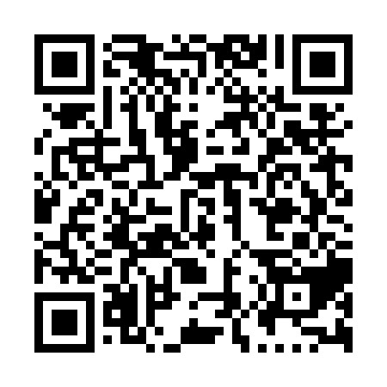
Prayer times for Saint-Sebastien-Station, Quebec, Canada
Mon 1 Jul 2024 - Wed 31 Jul 2024
High Latitude Method: Angle Based Rule
Prayer Calculation Method: Islamic Society of North America
Asar Calculation Method: Hanafi

Date | Day | Fajr | Sunrise | Dhuhr | Asr | Maghrib | Isha
1 | Mon | 2:59 | 4:58 | 12:48 | 6:11 | 8:37 | 10:36
2 | Tue | 3:00 | 4:59 | 12:48 | 6:11 | 8:37 | 10:36
3 | Wed | 3:01 | 5:00 | 12:48 | 6:11 | 8:37 | 10:35
4 | Thu | 3:02 | 5:00 | 12:48 | 6:11 | 8:36 | 10:34
5 | Fri | 3:03 | 5:01 | 12:49 | 6:11 | 8:36 | 10:33
6 | Sat | 3:04 | 5:02 | 12:49 | 6:11 | 8:36 | 10:32
7 | Sun | 3:06 | 5:02 | 12:49 | 6:11 | 8:35 | 10:32
8 | Mon | 3:07 | 5:03 | 12:49 | 6:11 | 8:35 | 10:31
9 | Tue | 3:08 | 5:04 | 12:49 | 6:10 | 8:34 | 10:30
10 | Wed | 3:10 | 5:05 | 12:49 | 6:10 | 8:34 | 10:28
11 | Thu | 3:11 | 5:06 | 12:49 | 6:10 | 8:33 | 10:27
12 | Fri | 3:12 | 5:07 | 12:50 | 6:10 | 8:32 | 10:26
13 | Sat | 3:14 | 5:07 | 12:50 | 6:09 | 8:32 | 10:25
14 | Sun | 3:15 | 5:08 | 12:50 | 6:09 | 8:31 | 10:23
15 | Mon | 3:17 | 5:09 | 12:50 | 6:09 | 8:30 | 10:22
16 | Tue | 3:19 | 5:10 | 12:50 | 6:08 | 8:29 | 10:21
17 | Wed | 3:20 | 5:11 | 12:50 | 6:08 | 8:28 | 10:19
18 | Thu | 3:22 | 5:12 | 12:50 | 6:07 | 8:28 | 10:18
19 | Fri | 3:23 | 5:13 | 12:50 | 6:07 | 8:27 | 10:16
20 | Sat | 3:25 | 5:14 | 12:50 | 6:06 | 8:26 | 10:15
21 | Sun | 3:27 | 5:15 | 12:50 | 6:06 | 8:25 | 10:13
22 | Mon | 3:28 | 5:16 | 12:50 | 6:05 | 8:24 | 10:11
23 | Tue | 3:30 | 5:18 | 12:50 | 6:05 | 8:23 | 10:10
24 | Wed | 3:32 | 5:19 | 12:50 | 6:04 | 8:22 | 10:08
25 | Thu | 3:34 | 5:20 | 12:50 | 6:03 | 8:21 | 10:06
26 | Fri | 3:35 | 5:21 | 12:50 | 6:03 | 8:19 | 10:05
27 | Sat | 3:37 | 5:22 | 12:50 | 6:02 | 8:18 | 10:03
28 | Sun | 3:39 | 5:23 | 12:50 | 6:01 | 8:17 | 10:01
29 | Mon | 3:41 | 5:24 | 12:50 | 6:01 | 8:16 | 9:59
30 | Tue | 3:42 | 5:25 | 12:50 | 6:00 | 8:15 | 9:57
31 | Wed | 3:44 | 5:27 | 12:50 | 5:59 | 8:13 | 9:55
Prayer times provided by https://www.salahtimes.com

