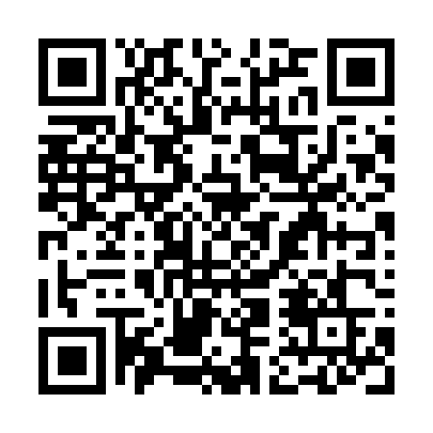

**Prayer times for Tamaris-sur-Mer, France**

**Sun 1 Dec 2024 - Tue 31 Dec 2024**

**High Latitude Method: Angle Based Rule**

**Prayer Calculation Method: Islamic Organisations Union of France**

**Asar Calculation Method: Shafi**

|  |  |  |  |  |  |  |  |
| --- | --- | --- | --- | --- | --- | --- | --- |
| **Date** | **Day** | **Fajr** | **Sunrise** | **Dhuhr** | **Asr** | **Maghrib** | **Isha** |
| 1 | Sun | 6:41 | 7:48 | 12:26 | 2:44 | 5:02 | 6:10 |
| 2 | Mon | 6:42 | 7:50 | 12:26 | 2:44 | 5:02 | 6:09 |
| 3 | Tue | 6:43 | 7:51 | 12:26 | 2:44 | 5:02 | 6:09 |
| 4 | Wed | 6:44 | 7:52 | 12:27 | 2:43 | 5:02 | 6:09 |
| 5 | Thu | 6:45 | 7:53 | 12:27 | 2:43 | 5:02 | 6:09 |
| 6 | Fri | 6:46 | 7:54 | 12:28 | 2:43 | 5:01 | 6:09 |
| 7 | Sat | 6:47 | 7:55 | 12:28 | 2:43 | 5:01 | 6:09 |
| 8 | Sun | 6:48 | 7:55 | 12:28 | 2:43 | 5:01 | 6:09 |
| 9 | Mon | 6:48 | 7:56 | 12:29 | 2:43 | 5:01 | 6:09 |
| 10 | Tue | 6:49 | 7:57 | 12:29 | 2:44 | 5:01 | 6:09 |
| 11 | Wed | 6:50 | 7:58 | 12:30 | 2:44 | 5:01 | 6:10 |
| 12 | Thu | 6:51 | 7:59 | 12:30 | 2:44 | 5:02 | 6:10 |
| 13 | Fri | 6:51 | 8:00 | 12:31 | 2:44 | 5:02 | 6:10 |
| 14 | Sat | 6:52 | 8:00 | 12:31 | 2:44 | 5:02 | 6:10 |
| 15 | Sun | 6:53 | 8:01 | 12:32 | 2:45 | 5:02 | 6:11 |
| 16 | Mon | 6:54 | 8:02 | 12:32 | 2:45 | 5:02 | 6:11 |
| 17 | Tue | 6:54 | 8:03 | 12:33 | 2:45 | 5:03 | 6:11 |
| 18 | Wed | 6:55 | 8:03 | 12:33 | 2:46 | 5:03 | 6:12 |
| 19 | Thu | 6:55 | 8:04 | 12:34 | 2:46 | 5:04 | 6:12 |
| 20 | Fri | 6:56 | 8:04 | 12:34 | 2:47 | 5:04 | 6:12 |
| 21 | Sat | 6:56 | 8:05 | 12:35 | 2:47 | 5:05 | 6:13 |
| 22 | Sun | 6:57 | 8:05 | 12:35 | 2:48 | 5:05 | 6:14 |
| 23 | Mon | 6:57 | 8:06 | 12:36 | 2:48 | 5:06 | 6:14 |
| 24 | Tue | 6:58 | 8:06 | 12:36 | 2:49 | 5:06 | 6:15 |
| 25 | Wed | 6:58 | 8:07 | 12:37 | 2:49 | 5:07 | 6:15 |
| 26 | Thu | 6:59 | 8:07 | 12:37 | 2:50 | 5:08 | 6:16 |
| 27 | Fri | 6:59 | 8:07 | 12:38 | 2:51 | 5:08 | 6:17 |
| 28 | Sat | 6:59 | 8:07 | 12:38 | 2:51 | 5:09 | 6:17 |
| 29 | Sun | 6:59 | 8:08 | 12:39 | 2:52 | 5:10 | 6:18 |
| 30 | Mon | 7:00 | 8:08 | 12:39 | 2:53 | 5:11 | 6:19 |
| 31 | Tue | 7:00 | 8:08 | 12:40 | 2:54 | 5:11 | 6:20 |

**Prayer times provided by https://www.salahtimes.com**