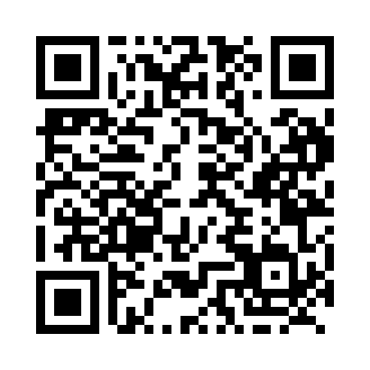

**Prayer times for Qullisaq, Quebec, Canada**

**Sun 1 Sep 2024 - Mon 30 Sep 2024**

**High Latitude Method: Angle Based Rule**

**Prayer Calculation Method: Islamic Society of North America**

**Asar Calculation Method: Hanafi**

|  |  |  |  |  |  |  |  |
| --- | --- | --- | --- | --- | --- | --- | --- |
| **Date** | **Day** | **Fajr** | **Sunrise** | **Dhuhr** | **Asr** | **Maghrib** | **Isha** |
| 1 | Sun | 3:25 | 5:52 | 1:00 | 5:38 | 8:06 | 10:33 |
| 2 | Mon | 3:26 | 5:54 | 12:59 | 5:36 | 8:03 | 10:30 |
| 3 | Tue | 3:30 | 5:57 | 12:59 | 5:33 | 8:00 | 10:25 |
| 4 | Wed | 3:35 | 5:59 | 12:59 | 5:31 | 7:57 | 10:20 |
| 5 | Thu | 3:39 | 6:02 | 12:58 | 5:28 | 7:53 | 10:15 |
| 6 | Fri | 3:43 | 6:04 | 12:58 | 5:26 | 7:50 | 10:11 |
| 7 | Sat | 3:47 | 6:07 | 12:58 | 5:23 | 7:47 | 10:06 |
| 8 | Sun | 3:51 | 6:10 | 12:57 | 5:21 | 7:44 | 10:01 |
| 9 | Mon | 3:55 | 6:12 | 12:57 | 5:18 | 7:40 | 9:57 |
| 10 | Tue | 3:59 | 6:15 | 12:57 | 5:16 | 7:37 | 9:53 |
| 11 | Wed | 4:02 | 6:17 | 12:56 | 5:13 | 7:34 | 9:48 |
| 12 | Thu | 4:06 | 6:20 | 12:56 | 5:10 | 7:31 | 9:44 |
| 13 | Fri | 4:10 | 6:22 | 12:56 | 5:08 | 7:27 | 9:40 |
| 14 | Sat | 4:13 | 6:25 | 12:55 | 5:05 | 7:24 | 9:35 |
| 15 | Sun | 4:17 | 6:27 | 12:55 | 5:03 | 7:21 | 9:31 |
| 16 | Mon | 4:20 | 6:30 | 12:55 | 5:00 | 7:18 | 9:27 |
| 17 | Tue | 4:23 | 6:33 | 12:54 | 4:57 | 7:14 | 9:23 |
| 18 | Wed | 4:27 | 6:35 | 12:54 | 4:55 | 7:11 | 9:19 |
| 19 | Thu | 4:30 | 6:38 | 12:53 | 4:52 | 7:08 | 9:15 |
| 20 | Fri | 4:33 | 6:40 | 12:53 | 4:49 | 7:05 | 9:11 |
| 21 | Sat | 4:36 | 6:43 | 12:53 | 4:47 | 7:01 | 9:07 |
| 22 | Sun | 4:39 | 6:45 | 12:52 | 4:44 | 6:58 | 9:04 |
| 23 | Mon | 4:42 | 6:48 | 12:52 | 4:41 | 6:55 | 9:00 |
| 24 | Tue | 4:46 | 6:50 | 12:52 | 4:38 | 6:52 | 8:56 |
| 25 | Wed | 4:49 | 6:53 | 12:51 | 4:36 | 6:48 | 8:52 |
| 26 | Thu | 4:52 | 6:55 | 12:51 | 4:33 | 6:45 | 8:49 |
| 27 | Fri | 4:55 | 6:58 | 12:51 | 4:30 | 6:42 | 8:45 |
| 28 | Sat | 4:57 | 7:01 | 12:50 | 4:27 | 6:39 | 8:41 |
| 29 | Sun | 5:00 | 7:03 | 12:50 | 4:25 | 6:35 | 8:38 |
| 30 | Mon | 5:03 | 7:06 | 12:50 | 4:22 | 6:32 | 8:34 |

**Prayer times provided by https://www.salahtimes.com**