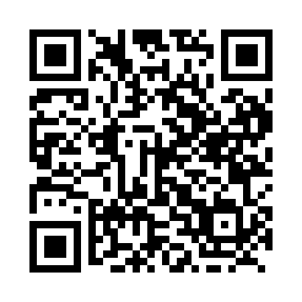
Prayer times for Big Salmon, Yukon, Canada
Wed 1 May 2024 - Fri 31 May 2024
High Latitude Method: Angle Based Rule
Prayer Calculation Method: Islamic Society of North America
Asar Calculation Method: Hanafi

Date | Day | Fajr | Sunrise | Dhuhr | Asr | Maghrib | Isha
1 | Wed | 3:51 | 5:44 | 1:57 | 7:18 | 10:10 | 12:04
2 | Thu | 3:49 | 5:41 | 1:57 | 7:19 | 10:13 | 12:05
3 | Fri | 3:48 | 5:38 | 1:57 | 7:21 | 10:16 | 12:07
4 | Sat | 3:46 | 5:36 | 1:56 | 7:23 | 10:19 | 12:08
5 | Sun | 3:45 | 5:33 | 1:56 | 7:24 | 10:21 | 12:09
6 | Mon | 3:43 | 5:30 | 1:56 | 7:26 | 10:24 | 12:11
7 | Tue | 3:42 | 5:27 | 1:56 | 7:27 | 10:27 | 12:12
8 | Wed | 3:40 | 5:24 | 1:56 | 7:29 | 10:30 | 12:13
9 | Thu | 3:39 | 5:21 | 1:56 | 7:30 | 10:32 | 12:15
10 | Fri | 3:38 | 5:18 | 1:56 | 7:31 | 10:35 | 12:16
11 | Sat | 3:36 | 5:16 | 1:56 | 7:33 | 10:38 | 12:17
12 | Sun | 3:35 | 5:13 | 1:56 | 7:34 | 10:41 | 12:19
13 | Mon | 3:33 | 5:10 | 1:56 | 7:36 | 10:43 | 12:20
14 | Tue | 3:32 | 5:07 | 1:56 | 7:37 | 10:46 | 12:21
15 | Wed | 3:31 | 5:05 | 1:56 | 7:38 | 10:49 | 12:23
16 | Thu | 3:29 | 5:02 | 1:56 | 7:40 | 10:51 | 12:24
17 | Fri | 3:28 | 5:00 | 1:56 | 7:41 | 10:54 | 12:25
18 | Sat | 3:27 | 4:57 | 1:56 | 7:42 | 10:57 | 12:27
19 | Sun | 3:26 | 4:54 | 1:56 | 7:44 | 10:59 | 12:28
20 | Mon | 3:24 | 4:52 | 1:56 | 7:45 | 11:02 | 12:29
21 | Tue | 3:23 | 4:50 | 1:56 | 7:46 | 11:04 | 12:31
22 | Wed | 3:22 | 4:47 | 1:56 | 7:47 | 11:07 | 12:32
23 | Thu | 3:21 | 4:45 | 1:57 | 7:48 | 11:09 | 12:33
24 | Fri | 3:20 | 4:43 | 1:57 | 7:50 | 11:12 | 12:35
25 | Sat | 3:19 | 4:40 | 1:57 | 7:51 | 11:14 | 12:36
26 | Sun | 3:18 | 4:38 | 1:57 | 7:52 | 11:17 | 12:37
27 | Mon | 3:17 | 4:36 | 1:57 | 7:53 | 11:19 | 12:38
28 | Tue | 3:16 | 4:34 | 1:57 | 7:54 | 11:21 | 12:39
29 | Wed | 3:15 | 4:32 | 1:57 | 7:55 | 11:23 | 12:41
30 | Thu | 3:14 | 4:30 | 1:57 | 7:56 | 11:26 | 12:42
31 | Fri | 3:13 | 4:28 | 1:58 | 7:57 | 11:28 | 12:43
Prayer times provided by https://www.salahtimes.com

