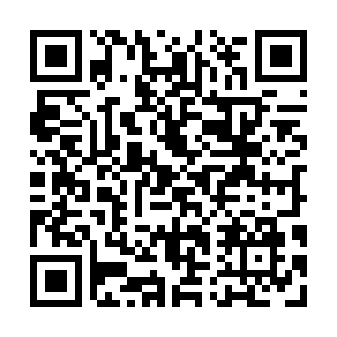
Prayer times for Gussetts Cove, Newfoundland and Labrador, Canada
Sat 1 Jun 2024 - Sun 30 Jun 2024
High Latitude Method: Angle Based Rule
Prayer Calculation Method: Islamic Society of North America
Asar Calculation Method: Hanafi

Date | Day | Fajr | Sunrise | Dhuhr | Asr | Maghrib | Isha
1 | Sat | 3:04 | 5:07 | 1:00 | 6:26 | 8:54 | 10:57
2 | Sun | 3:04 | 5:07 | 1:00 | 6:26 | 8:55 | 10:58
3 | Mon | 3:04 | 5:06 | 1:01 | 6:27 | 8:55 | 10:58
4 | Tue | 3:03 | 5:06 | 1:01 | 6:27 | 8:56 | 10:59
5 | Wed | 3:03 | 5:05 | 1:01 | 6:28 | 8:57 | 10:59
6 | Thu | 3:03 | 5:05 | 1:01 | 6:28 | 8:58 | 11:00
7 | Fri | 3:03 | 5:04 | 1:01 | 6:29 | 8:59 | 11:00
8 | Sat | 3:03 | 5:04 | 1:02 | 6:29 | 8:59 | 11:00
9 | Sun | 3:03 | 5:04 | 1:02 | 6:30 | 9:00 | 11:01
10 | Mon | 3:03 | 5:04 | 1:02 | 6:30 | 9:01 | 11:01
11 | Tue | 3:03 | 5:03 | 1:02 | 6:30 | 9:01 | 11:02
12 | Wed | 3:03 | 5:03 | 1:02 | 6:31 | 9:02 | 11:02
13 | Thu | 3:03 | 5:03 | 1:03 | 6:31 | 9:02 | 11:02
14 | Fri | 3:03 | 5:03 | 1:03 | 6:32 | 9:03 | 11:03
15 | Sat | 3:03 | 5:03 | 1:03 | 6:32 | 9:03 | 11:03
16 | Sun | 3:03 | 5:03 | 1:03 | 6:32 | 9:04 | 11:03
17 | Mon | 3:03 | 5:03 | 1:03 | 6:33 | 9:04 | 11:04
18 | Tue | 3:03 | 5:03 | 1:04 | 6:33 | 9:04 | 11:04
19 | Wed | 3:04 | 5:03 | 1:04 | 6:33 | 9:05 | 11:04
20 | Thu | 3:04 | 5:03 | 1:04 | 6:33 | 9:05 | 11:04
21 | Fri | 3:04 | 5:04 | 1:04 | 6:34 | 9:05 | 11:05
22 | Sat | 3:04 | 5:04 | 1:05 | 6:34 | 9:05 | 11:05
23 | Sun | 3:04 | 5:04 | 1:05 | 6:34 | 9:05 | 11:05
24 | Mon | 3:05 | 5:04 | 1:05 | 6:34 | 9:05 | 11:05
25 | Tue | 3:05 | 5:05 | 1:05 | 6:34 | 9:05 | 11:05
26 | Wed | 3:05 | 5:05 | 1:05 | 6:34 | 9:05 | 11:05
27 | Thu | 3:06 | 5:06 | 1:06 | 6:34 | 9:05 | 11:05
28 | Fri | 3:06 | 5:06 | 1:06 | 6:34 | 9:05 | 11:05
29 | Sat | 3:06 | 5:07 | 1:06 | 6:34 | 9:05 | 11:05
30 | Sun | 3:07 | 5:07 | 1:06 | 6:34 | 9:05 | 11:05
Prayer times provided by https://www.salahtimes.com

