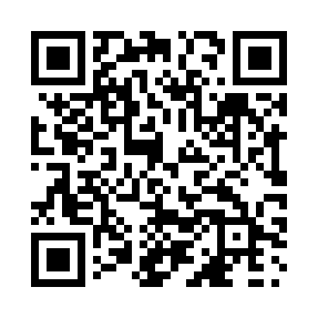
Prayer times for Brock, Saskatchewan, Canada
Wed 1 May 2024 - Fri 31 May 2024
High Latitude Method: Angle Based Rule
Prayer Calculation Method: Islamic Society of North America
Asar Calculation Method: Hanafi

Date | Day | Fajr | Sunrise | Dhuhr | Asr | Maghrib | Isha
1 | Wed | 3:49 | 5:46 | 1:12 | 6:19 | 8:39 | 10:36
2 | Thu | 3:46 | 5:44 | 1:12 | 6:20 | 8:41 | 10:39
3 | Fri | 3:43 | 5:42 | 1:12 | 6:21 | 8:42 | 10:42
4 | Sat | 3:40 | 5:40 | 1:12 | 6:22 | 8:44 | 10:44
5 | Sun | 3:37 | 5:38 | 1:12 | 6:23 | 8:46 | 10:47
6 | Mon | 3:35 | 5:37 | 1:11 | 6:24 | 8:47 | 10:50
7 | Tue | 3:32 | 5:35 | 1:11 | 6:25 | 8:49 | 10:53
8 | Wed | 3:29 | 5:33 | 1:11 | 6:26 | 8:50 | 10:56
9 | Thu | 3:26 | 5:31 | 1:11 | 6:27 | 8:52 | 10:58
10 | Fri | 3:23 | 5:30 | 1:11 | 6:28 | 8:53 | 11:01
11 | Sat | 3:20 | 5:28 | 1:11 | 6:29 | 8:55 | 11:03
12 | Sun | 3:19 | 5:27 | 1:11 | 6:30 | 8:57 | 11:04
13 | Mon | 3:18 | 5:25 | 1:11 | 6:31 | 8:58 | 11:05
14 | Tue | 3:18 | 5:24 | 1:11 | 6:32 | 9:00 | 11:06
15 | Wed | 3:17 | 5:22 | 1:11 | 6:33 | 9:01 | 11:06
16 | Thu | 3:16 | 5:21 | 1:11 | 6:33 | 9:03 | 11:07
17 | Fri | 3:15 | 5:19 | 1:11 | 6:34 | 9:04 | 11:08
18 | Sat | 3:15 | 5:18 | 1:11 | 6:35 | 9:05 | 11:09
19 | Sun | 3:14 | 5:17 | 1:11 | 6:36 | 9:07 | 11:09
20 | Mon | 3:14 | 5:15 | 1:11 | 6:37 | 9:08 | 11:10
21 | Tue | 3:13 | 5:14 | 1:12 | 6:38 | 9:10 | 11:11
22 | Wed | 3:12 | 5:13 | 1:12 | 6:38 | 9:11 | 11:11
23 | Thu | 3:12 | 5:12 | 1:12 | 6:39 | 9:12 | 11:12
24 | Fri | 3:11 | 5:11 | 1:12 | 6:40 | 9:14 | 11:13
25 | Sat | 3:11 | 5:09 | 1:12 | 6:41 | 9:15 | 11:14
26 | Sun | 3:10 | 5:08 | 1:12 | 6:41 | 9:16 | 11:14
27 | Mon | 3:10 | 5:07 | 1:12 | 6:42 | 9:17 | 11:15
28 | Tue | 3:10 | 5:06 | 1:12 | 6:43 | 9:19 | 11:16
29 | Wed | 3:09 | 5:06 | 1:12 | 6:44 | 9:20 | 11:16
30 | Thu | 3:09 | 5:05 | 1:13 | 6:44 | 9:21 | 11:17
31 | Fri | 3:08 | 5:04 | 1:13 | 6:45 | 9:22 | 11:17
Prayer times provided by https://www.salahtimes.com

