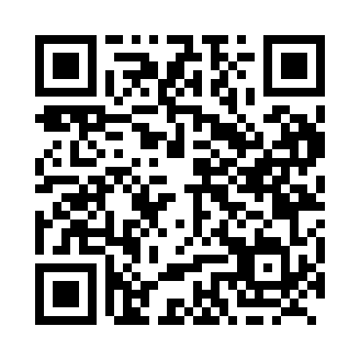
Prayer times for Carmacks, Yukon, Canada
Wed 1 May 2024 - Fri 31 May 2024
High Latitude Method: Angle Based Rule
Prayer Calculation Method: Islamic Society of North America
Asar Calculation Method: Hanafi

Date | Day | Fajr | Sunrise | Dhuhr | Asr | Maghrib | Isha
1 | Wed | 3:56 | 5:49 | 2:02 | 7:24 | 10:17 | 12:10
2 | Thu | 3:54 | 5:46 | 2:02 | 7:25 | 10:20 | 12:11
3 | Fri | 3:53 | 5:43 | 2:02 | 7:27 | 10:23 | 12:13
4 | Sat | 3:51 | 5:40 | 2:02 | 7:28 | 10:26 | 12:14
5 | Sun | 3:50 | 5:37 | 2:02 | 7:30 | 10:28 | 12:16
6 | Mon | 3:48 | 5:34 | 2:02 | 7:31 | 10:31 | 12:17
7 | Tue | 3:47 | 5:31 | 2:02 | 7:33 | 10:34 | 12:18
8 | Wed | 3:45 | 5:28 | 2:02 | 7:34 | 10:37 | 12:20
9 | Thu | 3:44 | 5:25 | 2:02 | 7:36 | 10:40 | 12:21
10 | Fri | 3:42 | 5:22 | 2:02 | 7:37 | 10:42 | 12:22
11 | Sat | 3:41 | 5:19 | 2:02 | 7:39 | 10:45 | 12:24
12 | Sun | 3:39 | 5:17 | 2:02 | 7:40 | 10:48 | 12:25
13 | Mon | 3:38 | 5:14 | 2:02 | 7:42 | 10:51 | 12:26
14 | Tue | 3:37 | 5:11 | 2:02 | 7:43 | 10:53 | 12:28
15 | Wed | 3:35 | 5:08 | 2:02 | 7:44 | 10:56 | 12:29
16 | Thu | 3:34 | 5:06 | 2:02 | 7:46 | 10:59 | 12:31
17 | Fri | 3:33 | 5:03 | 2:02 | 7:47 | 11:02 | 12:32
18 | Sat | 3:31 | 5:00 | 2:02 | 7:48 | 11:04 | 12:33
19 | Sun | 3:30 | 4:58 | 2:02 | 7:50 | 11:07 | 12:35
20 | Mon | 3:29 | 4:55 | 2:02 | 7:51 | 11:09 | 12:36
21 | Tue | 3:28 | 4:53 | 2:02 | 7:52 | 11:12 | 12:37
22 | Wed | 3:27 | 4:51 | 2:02 | 7:53 | 11:15 | 12:39
23 | Thu | 3:25 | 4:48 | 2:02 | 7:55 | 11:17 | 12:40
24 | Fri | 3:24 | 4:46 | 2:02 | 7:56 | 11:20 | 12:41
25 | Sat | 3:23 | 4:44 | 2:02 | 7:57 | 11:22 | 12:42
26 | Sun | 3:22 | 4:41 | 2:02 | 7:58 | 11:24 | 12:44
27 | Mon | 3:21 | 4:39 | 2:02 | 7:59 | 11:27 | 12:45
28 | Tue | 3:20 | 4:37 | 2:03 | 8:00 | 11:29 | 12:46
29 | Wed | 3:19 | 4:35 | 2:03 | 8:01 | 11:31 | 12:47
30 | Thu | 3:18 | 4:33 | 2:03 | 8:02 | 11:34 | 12:48
31 | Fri | 3:17 | 4:31 | 2:03 | 8:03 | 11:36 | 12:50
Prayer times provided by https://www.salahtimes.com

