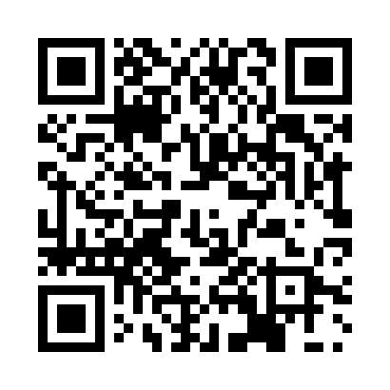
Prayer times for Eekhout, Belgium
Mon 1 Apr 2024 - Tue 30 Apr 2024
High Latitude Method: Angle Based Rule
Prayer Calculation Method: Muslim World League
Asar Calculation Method: Shafi

Date | Day | Fajr | Sunrise | Dhuhr | Asr | Maghrib | Isha
1 | Mon | 5:22 | 7:19 | 1:48 | 5:21 | 8:17 | 10:07
2 | Tue | 5:19 | 7:17 | 1:47 | 5:22 | 8:19 | 10:09
3 | Wed | 5:16 | 7:14 | 1:47 | 5:23 | 8:21 | 10:11
4 | Thu | 5:13 | 7:12 | 1:47 | 5:24 | 8:22 | 10:14
5 | Fri | 5:11 | 7:10 | 1:46 | 5:24 | 8:24 | 10:16
6 | Sat | 5:08 | 7:08 | 1:46 | 5:25 | 8:25 | 10:18
7 | Sun | 5:05 | 7:06 | 1:46 | 5:26 | 8:27 | 10:20
8 | Mon | 5:02 | 7:03 | 1:46 | 5:27 | 8:29 | 10:23
9 | Tue | 4:59 | 7:01 | 1:45 | 5:28 | 8:30 | 10:25
10 | Wed | 4:56 | 6:59 | 1:45 | 5:28 | 8:32 | 10:27
11 | Thu | 4:53 | 6:57 | 1:45 | 5:29 | 8:34 | 10:29
12 | Fri | 4:50 | 6:55 | 1:45 | 5:30 | 8:35 | 10:32
13 | Sat | 4:47 | 6:53 | 1:44 | 5:31 | 8:37 | 10:34
14 | Sun | 4:44 | 6:50 | 1:44 | 5:32 | 8:39 | 10:36
15 | Mon | 4:41 | 6:48 | 1:44 | 5:32 | 8:40 | 10:39
16 | Tue | 4:38 | 6:46 | 1:44 | 5:33 | 8:42 | 10:41
17 | Wed | 4:35 | 6:44 | 1:43 | 5:34 | 8:43 | 10:44
18 | Thu | 4:32 | 6:42 | 1:43 | 5:34 | 8:45 | 10:46
19 | Fri | 4:29 | 6:40 | 1:43 | 5:35 | 8:47 | 10:49
20 | Sat | 4:26 | 6:38 | 1:43 | 5:36 | 8:48 | 10:51
21 | Sun | 4:23 | 6:36 | 1:42 | 5:37 | 8:50 | 10:54
22 | Mon | 4:20 | 6:34 | 1:42 | 5:37 | 8:52 | 10:57
23 | Tue | 4:17 | 6:32 | 1:42 | 5:38 | 8:53 | 10:59
24 | Wed | 4:14 | 6:30 | 1:42 | 5:39 | 8:55 | 11:02
25 | Thu | 4:10 | 6:28 | 1:42 | 5:39 | 8:56 | 11:05
26 | Fri | 4:07 | 6:26 | 1:42 | 5:40 | 8:58 | 11:07
27 | Sat | 4:04 | 6:24 | 1:41 | 5:41 | 9:00 | 11:10
28 | Sun | 4:01 | 6:22 | 1:41 | 5:41 | 9:01 | 11:13
29 | Mon | 3:57 | 6:20 | 1:41 | 5:42 | 9:03 | 11:16
30 | Tue | 3:54 | 6:18 | 1:41 | 5:43 | 9:05 | 11:19
Prayer times provided by https://www.salahtimes.com

