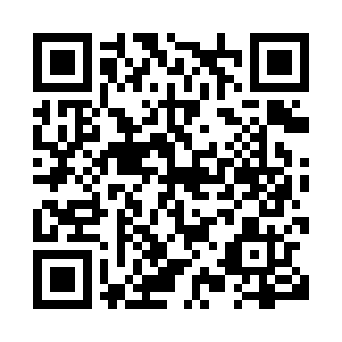

**Prayer times for Nelson Forks, British Columbia, Canada**

**Sun 1 Sep 2024 - Mon 30 Sep 2024**

**High Latitude Method: Angle Based Rule**

**Prayer Calculation Method: Islamic Society of North America**

**Asar Calculation Method: Hanafi**

|  |  |  |  |  |  |  |  |
| --- | --- | --- | --- | --- | --- | --- | --- |
| **Date** | **Day** | **Fajr** | **Sunrise** | **Dhuhr** | **Asr** | **Maghrib** | **Isha** |
| 1 | Sun | 4:01 | 6:14 | 1:16 | 5:54 | 8:16 | 10:29 |
| 2 | Mon | 4:04 | 6:16 | 1:15 | 5:52 | 8:13 | 10:25 |
| 3 | Tue | 4:08 | 6:19 | 1:15 | 5:50 | 8:10 | 10:20 |
| 4 | Wed | 4:11 | 6:21 | 1:15 | 5:47 | 8:07 | 10:16 |
| 5 | Thu | 4:15 | 6:23 | 1:14 | 5:45 | 8:04 | 10:12 |
| 6 | Fri | 4:18 | 6:26 | 1:14 | 5:43 | 8:01 | 10:08 |
| 7 | Sat | 4:21 | 6:28 | 1:14 | 5:40 | 7:58 | 10:04 |
| 8 | Sun | 4:25 | 6:30 | 1:13 | 5:38 | 7:55 | 10:00 |
| 9 | Mon | 4:28 | 6:32 | 1:13 | 5:36 | 7:52 | 9:56 |
| 10 | Tue | 4:31 | 6:35 | 1:13 | 5:33 | 7:49 | 9:53 |
| 11 | Wed | 4:34 | 6:37 | 1:12 | 5:31 | 7:46 | 9:49 |
| 12 | Thu | 4:37 | 6:39 | 1:12 | 5:29 | 7:43 | 9:45 |
| 13 | Fri | 4:40 | 6:42 | 1:12 | 5:26 | 7:40 | 9:41 |
| 14 | Sat | 4:43 | 6:44 | 1:11 | 5:24 | 7:37 | 9:38 |
| 15 | Sun | 4:46 | 6:46 | 1:11 | 5:21 | 7:34 | 9:34 |
| 16 | Mon | 4:49 | 6:48 | 1:11 | 5:19 | 7:31 | 9:30 |
| 17 | Tue | 4:52 | 6:51 | 1:10 | 5:16 | 7:28 | 9:27 |
| 18 | Wed | 4:55 | 6:53 | 1:10 | 5:14 | 7:25 | 9:23 |
| 19 | Thu | 4:58 | 6:55 | 1:10 | 5:11 | 7:22 | 9:20 |
| 20 | Fri | 5:01 | 6:58 | 1:09 | 5:09 | 7:19 | 9:16 |
| 21 | Sat | 5:03 | 7:00 | 1:09 | 5:06 | 7:16 | 9:13 |
| 22 | Sun | 5:06 | 7:02 | 1:08 | 5:04 | 7:13 | 9:09 |
| 23 | Mon | 5:09 | 7:04 | 1:08 | 5:01 | 7:10 | 9:06 |
| 24 | Tue | 5:11 | 7:07 | 1:08 | 4:59 | 7:07 | 9:03 |
| 25 | Wed | 5:14 | 7:09 | 1:07 | 4:56 | 7:04 | 8:59 |
| 26 | Thu | 5:17 | 7:11 | 1:07 | 4:54 | 7:02 | 8:56 |
| 27 | Fri | 5:19 | 7:14 | 1:07 | 4:51 | 6:59 | 8:53 |
| 28 | Sat | 5:22 | 7:16 | 1:06 | 4:49 | 6:56 | 8:49 |
| 29 | Sun | 5:24 | 7:18 | 1:06 | 4:46 | 6:53 | 8:46 |
| 30 | Mon | 5:27 | 7:21 | 1:06 | 4:43 | 6:50 | 8:43 |

**Prayer times provided by https://www.salahtimes.com**