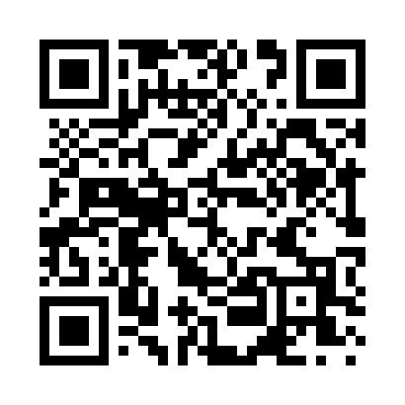
Prayer times for Eckers Lakeland, Wisconsin, USA
Mon 1 Jul 2024 - Wed 31 Jul 2024
High Latitude Method: Angle Based Rule
Prayer Calculation Method: Islamic Society of North America
Asar Calculation Method: Shafi

Date | Day | Fajr | Sunrise | Dhuhr | Asr | Maghrib | Isha
1 | Mon | 3:24 | 5:15 | 12:57 | 5:04 | 8:40 | 10:30
2 | Tue | 3:25 | 5:15 | 12:58 | 5:04 | 8:40 | 10:30
3 | Wed | 3:26 | 5:16 | 12:58 | 5:04 | 8:39 | 10:29
4 | Thu | 3:27 | 5:16 | 12:58 | 5:04 | 8:39 | 10:29
5 | Fri | 3:28 | 5:17 | 12:58 | 5:04 | 8:39 | 10:28
6 | Sat | 3:29 | 5:18 | 12:58 | 5:04 | 8:38 | 10:27
7 | Sun | 3:30 | 5:19 | 12:58 | 5:04 | 8:38 | 10:26
8 | Mon | 3:31 | 5:19 | 12:59 | 5:04 | 8:37 | 10:26
9 | Tue | 3:32 | 5:20 | 12:59 | 5:04 | 8:37 | 10:25
10 | Wed | 3:33 | 5:21 | 12:59 | 5:04 | 8:36 | 10:24
11 | Thu | 3:34 | 5:22 | 12:59 | 5:04 | 8:36 | 10:23
12 | Fri | 3:36 | 5:22 | 12:59 | 5:04 | 8:35 | 10:22
13 | Sat | 3:37 | 5:23 | 12:59 | 5:04 | 8:35 | 10:21
14 | Sun | 3:38 | 5:24 | 12:59 | 5:04 | 8:34 | 10:19
15 | Mon | 3:40 | 5:25 | 12:59 | 5:04 | 8:33 | 10:18
16 | Tue | 3:41 | 5:26 | 12:59 | 5:04 | 8:33 | 10:17
17 | Wed | 3:43 | 5:27 | 1:00 | 5:04 | 8:32 | 10:16
18 | Thu | 3:44 | 5:28 | 1:00 | 5:03 | 8:31 | 10:15
19 | Fri | 3:45 | 5:29 | 1:00 | 5:03 | 8:30 | 10:13
20 | Sat | 3:47 | 5:30 | 1:00 | 5:03 | 8:29 | 10:12
21 | Sun | 3:48 | 5:31 | 1:00 | 5:03 | 8:28 | 10:10
22 | Mon | 3:50 | 5:32 | 1:00 | 5:02 | 8:27 | 10:09
23 | Tue | 3:51 | 5:33 | 1:00 | 5:02 | 8:27 | 10:07
24 | Wed | 3:53 | 5:34 | 1:00 | 5:02 | 8:26 | 10:06
25 | Thu | 3:54 | 5:35 | 1:00 | 5:02 | 8:24 | 10:04
26 | Fri | 3:56 | 5:36 | 1:00 | 5:01 | 8:23 | 10:03
27 | Sat | 3:58 | 5:37 | 1:00 | 5:01 | 8:22 | 10:01
28 | Sun | 3:59 | 5:38 | 1:00 | 5:00 | 8:21 | 10:00
29 | Mon | 4:01 | 5:39 | 1:00 | 5:00 | 8:20 | 9:58
30 | Tue | 4:02 | 5:40 | 1:00 | 5:00 | 8:19 | 9:56
31 | Wed | 4:04 | 5:41 | 1:00 | 4:59 | 8:18 | 9:54
Prayer times provided by https://www.salahtimes.com

