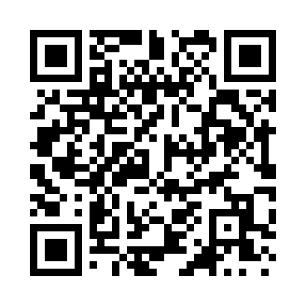
Prayer times for Cram, Arkansas, USA
Mon 1 Apr 2024 - Tue 30 Apr 2024
High Latitude Method: Angle Based Rule
Prayer Calculation Method: Islamic Society of North America
Asar Calculation Method: Shafi

Date | Day | Fajr | Sunrise | Dhuhr | Asr | Maghrib | Isha
1 | Mon | 5:47 | 6:56 | 1:13 | 4:47 | 7:31 | 8:40
2 | Tue | 5:46 | 6:55 | 1:13 | 4:47 | 7:31 | 8:41
3 | Wed | 5:44 | 6:54 | 1:13 | 4:47 | 7:32 | 8:42
4 | Thu | 5:43 | 6:52 | 1:12 | 4:47 | 7:33 | 8:43
5 | Fri | 5:41 | 6:51 | 1:12 | 4:47 | 7:33 | 8:43
6 | Sat | 5:40 | 6:50 | 1:12 | 4:47 | 7:34 | 8:44
7 | Sun | 5:38 | 6:48 | 1:11 | 4:47 | 7:35 | 8:45
8 | Mon | 5:37 | 6:47 | 1:11 | 4:47 | 7:36 | 8:46
9 | Tue | 5:35 | 6:46 | 1:11 | 4:47 | 7:36 | 8:47
10 | Wed | 5:34 | 6:45 | 1:11 | 4:48 | 7:37 | 8:48
11 | Thu | 5:33 | 6:43 | 1:10 | 4:48 | 7:38 | 8:49
12 | Fri | 5:31 | 6:42 | 1:10 | 4:48 | 7:39 | 8:50
13 | Sat | 5:30 | 6:41 | 1:10 | 4:48 | 7:39 | 8:51
14 | Sun | 5:28 | 6:40 | 1:10 | 4:48 | 7:40 | 8:52
15 | Mon | 5:27 | 6:38 | 1:09 | 4:48 | 7:41 | 8:53
16 | Tue | 5:26 | 6:37 | 1:09 | 4:48 | 7:42 | 8:53
17 | Wed | 5:24 | 6:36 | 1:09 | 4:48 | 7:42 | 8:54
18 | Thu | 5:23 | 6:35 | 1:09 | 4:48 | 7:43 | 8:55
19 | Fri | 5:21 | 6:34 | 1:09 | 4:48 | 7:44 | 8:56
20 | Sat | 5:20 | 6:32 | 1:08 | 4:48 | 7:45 | 8:57
21 | Sun | 5:19 | 6:31 | 1:08 | 4:48 | 7:45 | 8:58
22 | Mon | 5:17 | 6:30 | 1:08 | 4:48 | 7:46 | 8:59
23 | Tue | 5:16 | 6:29 | 1:08 | 4:48 | 7:47 | 9:00
24 | Wed | 5:15 | 6:28 | 1:08 | 4:48 | 7:48 | 9:01
25 | Thu | 5:13 | 6:27 | 1:07 | 4:48 | 7:48 | 9:02
26 | Fri | 5:12 | 6:26 | 1:07 | 4:48 | 7:49 | 9:03
27 | Sat | 5:11 | 6:25 | 1:07 | 4:48 | 7:50 | 9:04
28 | Sun | 5:09 | 6:24 | 1:07 | 4:49 | 7:51 | 9:05
29 | Mon | 5:08 | 6:23 | 1:07 | 4:49 | 7:52 | 9:06
30 | Tue | 5:07 | 6:22 | 1:07 | 4:49 | 7:52 | 9:07
Prayer times provided by https://www.salahtimes.com

