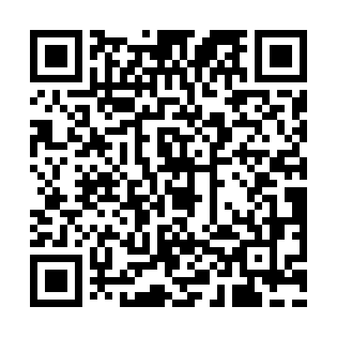

**Prayer times for Mont d'Aulages, France**

**Sun 1 Sep 2024 - Mon 30 Sep 2024**

**High Latitude Method: Angle Based Rule**

**Prayer Calculation Method: Islamic Organisations Union of France**

**Asar Calculation Method: Shafi**

|  |  |  |  |  |  |  |  |
| --- | --- | --- | --- | --- | --- | --- | --- |
| **Date** | **Day** | **Fajr** | **Sunrise** | **Dhuhr** | **Asr** | **Maghrib** | **Isha** |
| 1 | Sun | 5:56 | 7:10 | 1:54 | 5:37 | 8:37 | 9:51 |
| 2 | Mon | 5:58 | 7:12 | 1:54 | 5:35 | 8:35 | 9:49 |
| 3 | Tue | 6:00 | 7:13 | 1:53 | 5:34 | 8:33 | 9:46 |
| 4 | Wed | 6:01 | 7:15 | 1:53 | 5:33 | 8:31 | 9:44 |
| 5 | Thu | 6:03 | 7:16 | 1:53 | 5:31 | 8:29 | 9:41 |
| 6 | Fri | 6:05 | 7:18 | 1:52 | 5:30 | 8:26 | 9:39 |
| 7 | Sat | 6:06 | 7:19 | 1:52 | 5:29 | 8:24 | 9:37 |
| 8 | Sun | 6:08 | 7:21 | 1:52 | 5:27 | 8:22 | 9:34 |
| 9 | Mon | 6:10 | 7:22 | 1:51 | 5:26 | 8:20 | 9:32 |
| 10 | Tue | 6:12 | 7:23 | 1:51 | 5:24 | 8:18 | 9:30 |
| 11 | Wed | 6:13 | 7:25 | 1:51 | 5:23 | 8:16 | 9:27 |
| 12 | Thu | 6:15 | 7:26 | 1:50 | 5:21 | 8:13 | 9:25 |
| 13 | Fri | 6:17 | 7:28 | 1:50 | 5:20 | 8:11 | 9:22 |
| 14 | Sat | 6:18 | 7:29 | 1:50 | 5:18 | 8:09 | 9:20 |
| 15 | Sun | 6:20 | 7:31 | 1:49 | 5:17 | 8:07 | 9:18 |
| 16 | Mon | 6:22 | 7:32 | 1:49 | 5:15 | 8:05 | 9:15 |
| 17 | Tue | 6:23 | 7:34 | 1:49 | 5:14 | 8:02 | 9:13 |
| 18 | Wed | 6:25 | 7:35 | 1:48 | 5:12 | 8:00 | 9:11 |
| 19 | Thu | 6:26 | 7:37 | 1:48 | 5:11 | 7:58 | 9:08 |
| 20 | Fri | 6:28 | 7:38 | 1:48 | 5:09 | 7:56 | 9:06 |
| 21 | Sat | 6:30 | 7:40 | 1:47 | 5:08 | 7:54 | 9:04 |
| 22 | Sun | 6:31 | 7:41 | 1:47 | 5:06 | 7:51 | 9:01 |
| 23 | Mon | 6:33 | 7:43 | 1:46 | 5:05 | 7:49 | 8:59 |
| 24 | Tue | 6:34 | 7:44 | 1:46 | 5:03 | 7:47 | 8:57 |
| 25 | Wed | 6:36 | 7:46 | 1:46 | 5:01 | 7:45 | 8:55 |
| 26 | Thu | 6:38 | 7:47 | 1:45 | 5:00 | 7:43 | 8:52 |
| 27 | Fri | 6:39 | 7:49 | 1:45 | 4:58 | 7:41 | 8:50 |
| 28 | Sat | 6:41 | 7:50 | 1:45 | 4:57 | 7:38 | 8:48 |
| 29 | Sun | 6:42 | 7:52 | 1:44 | 4:55 | 7:36 | 8:46 |
| 30 | Mon | 6:44 | 7:53 | 1:44 | 4:53 | 7:34 | 8:43 |

**Prayer times provided by https://www.salahtimes.com**