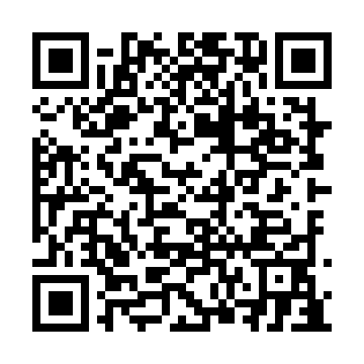
Prayer times for Cascapedia - Saint-Jules, Quebec, Canada
Wed 1 May 2024 - Fri 31 May 2024
High Latitude Method: Angle Based Rule
Prayer Calculation Method: Islamic Society of North America
Asar Calculation Method: Hanafi

Date | Day | Fajr | Sunrise | Dhuhr | Asr | Maghrib | Isha
1 | Wed | 3:20 | 5:04 | 12:21 | 5:25 | 7:38 | 9:22
2 | Thu | 3:18 | 5:02 | 12:21 | 5:25 | 7:40 | 9:25
3 | Fri | 3:15 | 5:01 | 12:20 | 5:26 | 7:41 | 9:27
4 | Sat | 3:13 | 4:59 | 12:20 | 5:27 | 7:42 | 9:29
5 | Sun | 3:11 | 4:57 | 12:20 | 5:28 | 7:44 | 9:31
6 | Mon | 3:08 | 4:56 | 12:20 | 5:29 | 7:45 | 9:33
7 | Tue | 3:06 | 4:54 | 12:20 | 5:30 | 7:47 | 9:35
8 | Wed | 3:04 | 4:53 | 12:20 | 5:30 | 7:48 | 9:38
9 | Thu | 3:02 | 4:51 | 12:20 | 5:31 | 7:49 | 9:40
10 | Fri | 2:59 | 4:50 | 12:20 | 5:32 | 7:51 | 9:42
11 | Sat | 2:57 | 4:49 | 12:20 | 5:33 | 7:52 | 9:44
12 | Sun | 2:55 | 4:47 | 12:20 | 5:34 | 7:53 | 9:46
13 | Mon | 2:53 | 4:46 | 12:20 | 5:35 | 7:55 | 9:48
14 | Tue | 2:51 | 4:45 | 12:20 | 5:35 | 7:56 | 9:51
15 | Wed | 2:48 | 4:43 | 12:20 | 5:36 | 7:57 | 9:53
16 | Thu | 2:46 | 4:42 | 12:20 | 5:37 | 7:59 | 9:55
17 | Fri | 2:44 | 4:41 | 12:20 | 5:38 | 8:00 | 9:57
18 | Sat | 2:42 | 4:40 | 12:20 | 5:38 | 8:01 | 9:59
19 | Sun | 2:40 | 4:39 | 12:20 | 5:39 | 8:02 | 10:01
20 | Mon | 2:38 | 4:37 | 12:20 | 5:40 | 8:04 | 10:03
21 | Tue | 2:36 | 4:36 | 12:20 | 5:41 | 8:05 | 10:06
22 | Wed | 2:34 | 4:35 | 12:20 | 5:41 | 8:06 | 10:08
23 | Thu | 2:32 | 4:34 | 12:20 | 5:42 | 8:07 | 10:10
24 | Fri | 2:30 | 4:33 | 12:21 | 5:43 | 8:08 | 10:12
25 | Sat | 2:29 | 4:32 | 12:21 | 5:43 | 8:10 | 10:14
26 | Sun | 2:27 | 4:31 | 12:21 | 5:44 | 8:11 | 10:16
27 | Mon | 2:26 | 4:31 | 12:21 | 5:45 | 8:12 | 10:16
28 | Tue | 2:26 | 4:30 | 12:21 | 5:45 | 8:13 | 10:17
29 | Wed | 2:25 | 4:29 | 12:21 | 5:46 | 8:14 | 10:18
30 | Thu | 2:25 | 4:28 | 12:21 | 5:46 | 8:15 | 10:18
31 | Fri | 2:25 | 4:28 | 12:21 | 5:47 | 8:16 | 10:19
Prayer times provided by https://www.salahtimes.com

