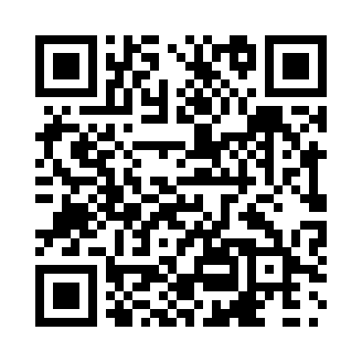
Prayer times for Ippikallak, Quebec, Canada
Mon 1 Jul 2024 - Wed 31 Jul 2024
High Latitude Method: Angle Based Rule
Prayer Calculation Method: Islamic Society of North America
Asar Calculation Method: Hanafi

Date | Day | Fajr | Sunrise | Dhuhr | Asr | Maghrib | Isha
1 | Mon | 2:06 | 3:28 | 12:44 | 6:41 | 9:59 | 11:21
2 | Tue | 2:06 | 3:29 | 12:44 | 6:41 | 9:58 | 11:21
3 | Wed | 2:07 | 3:30 | 12:44 | 6:41 | 9:58 | 11:21
4 | Thu | 2:08 | 3:32 | 12:44 | 6:40 | 9:57 | 11:20
5 | Fri | 2:09 | 3:33 | 12:45 | 6:40 | 9:56 | 11:20
6 | Sat | 2:09 | 3:34 | 12:45 | 6:40 | 9:55 | 11:19
7 | Sun | 2:10 | 3:36 | 12:45 | 6:39 | 9:53 | 11:19
8 | Mon | 2:11 | 3:37 | 12:45 | 6:39 | 9:52 | 11:18
9 | Tue | 2:12 | 3:39 | 12:45 | 6:38 | 9:51 | 11:18
10 | Wed | 2:13 | 3:40 | 12:45 | 6:38 | 9:49 | 11:17
11 | Thu | 2:14 | 3:42 | 12:45 | 6:37 | 9:48 | 11:17
12 | Fri | 2:14 | 3:44 | 12:46 | 6:36 | 9:47 | 11:16
13 | Sat | 2:15 | 3:46 | 12:46 | 6:36 | 9:45 | 11:15
14 | Sun | 2:16 | 3:47 | 12:46 | 6:35 | 9:43 | 11:14
15 | Mon | 2:17 | 3:49 | 12:46 | 6:34 | 9:42 | 11:14
16 | Tue | 2:18 | 3:51 | 12:46 | 6:33 | 9:40 | 11:13
17 | Wed | 2:19 | 3:53 | 12:46 | 6:33 | 9:38 | 11:12
18 | Thu | 2:20 | 3:55 | 12:46 | 6:32 | 9:36 | 11:11
19 | Fri | 2:21 | 3:57 | 12:46 | 6:31 | 9:34 | 11:10
20 | Sat | 2:22 | 3:59 | 12:46 | 6:30 | 9:32 | 11:09
21 | Sun | 2:23 | 4:01 | 12:46 | 6:29 | 9:30 | 11:08
22 | Mon | 2:25 | 4:03 | 12:46 | 6:28 | 9:28 | 11:07
23 | Tue | 2:26 | 4:05 | 12:46 | 6:27 | 9:26 | 11:06
24 | Wed | 2:27 | 4:08 | 12:46 | 6:26 | 9:24 | 11:05
25 | Thu | 2:28 | 4:10 | 12:46 | 6:25 | 9:22 | 11:04
26 | Fri | 2:29 | 4:12 | 12:46 | 6:23 | 9:20 | 11:03
27 | Sat | 2:30 | 4:14 | 12:46 | 6:22 | 9:18 | 11:02
28 | Sun | 2:31 | 4:16 | 12:46 | 6:21 | 9:15 | 11:00
29 | Mon | 2:32 | 4:19 | 12:46 | 6:20 | 9:13 | 10:59
30 | Tue | 2:33 | 4:21 | 12:46 | 6:18 | 9:11 | 10:58
31 | Wed | 2:34 | 4:23 | 12:46 | 6:17 | 9:08 | 10:57
Prayer times provided by https://www.salahtimes.com

