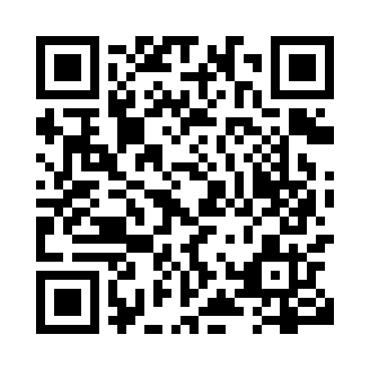
Prayer times for Hacheyville, New Brunswick, Canada
Wed 1 May 2024 - Fri 31 May 2024
High Latitude Method: Angle Based Rule
Prayer Calculation Method: Islamic Society of North America
Asar Calculation Method: Hanafi

Date | Day | Fajr | Sunrise | Dhuhr | Asr | Maghrib | Isha
1 | Wed | 4:21 | 6:02 | 1:17 | 6:20 | 8:33 | 10:15
2 | Thu | 4:18 | 6:01 | 1:17 | 6:21 | 8:34 | 10:17
3 | Fri | 4:16 | 5:59 | 1:17 | 6:22 | 8:36 | 10:19
4 | Sat | 4:14 | 5:58 | 1:17 | 6:23 | 8:37 | 10:21
5 | Sun | 4:12 | 5:56 | 1:17 | 6:24 | 8:38 | 10:23
6 | Mon | 4:09 | 5:55 | 1:17 | 6:25 | 8:40 | 10:25
7 | Tue | 4:07 | 5:53 | 1:17 | 6:25 | 8:41 | 10:27
8 | Wed | 4:05 | 5:52 | 1:17 | 6:26 | 8:43 | 10:29
9 | Thu | 4:03 | 5:50 | 1:17 | 6:27 | 8:44 | 10:32
10 | Fri | 4:01 | 5:49 | 1:17 | 6:28 | 8:45 | 10:34
11 | Sat | 3:59 | 5:47 | 1:17 | 6:29 | 8:46 | 10:36
12 | Sun | 3:57 | 5:46 | 1:17 | 6:29 | 8:48 | 10:38
13 | Mon | 3:55 | 5:45 | 1:17 | 6:30 | 8:49 | 10:40
14 | Tue | 3:52 | 5:43 | 1:17 | 6:31 | 8:50 | 10:42
15 | Wed | 3:50 | 5:42 | 1:17 | 6:32 | 8:52 | 10:44
16 | Thu | 3:48 | 5:41 | 1:17 | 6:32 | 8:53 | 10:46
17 | Fri | 3:46 | 5:40 | 1:17 | 6:33 | 8:54 | 10:48
18 | Sat | 3:44 | 5:39 | 1:17 | 6:34 | 8:55 | 10:50
19 | Sun | 3:43 | 5:38 | 1:17 | 6:34 | 8:57 | 10:52
20 | Mon | 3:41 | 5:36 | 1:17 | 6:35 | 8:58 | 10:54
21 | Tue | 3:39 | 5:35 | 1:17 | 6:36 | 8:59 | 10:56
22 | Wed | 3:37 | 5:34 | 1:17 | 6:37 | 9:00 | 10:58
23 | Thu | 3:35 | 5:33 | 1:17 | 6:37 | 9:01 | 11:00
24 | Fri | 3:33 | 5:32 | 1:17 | 6:38 | 9:02 | 11:02
25 | Sat | 3:32 | 5:32 | 1:17 | 6:39 | 9:03 | 11:04
26 | Sun | 3:30 | 5:31 | 1:17 | 6:39 | 9:04 | 11:06
27 | Mon | 3:28 | 5:30 | 1:17 | 6:40 | 9:06 | 11:07
28 | Tue | 3:27 | 5:29 | 1:18 | 6:41 | 9:07 | 11:09
29 | Wed | 3:25 | 5:28 | 1:18 | 6:41 | 9:08 | 11:11
30 | Thu | 3:24 | 5:28 | 1:18 | 6:42 | 9:09 | 11:13
31 | Fri | 3:23 | 5:27 | 1:18 | 6:42 | 9:09 | 11:14
Prayer times provided by https://www.salahtimes.com

