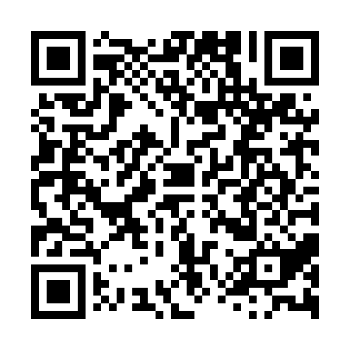
Prayer times for San Salvador Island, Bahamas
Wed 1 May 2024 - Fri 31 May 2024
High Latitude Method: None
Prayer Calculation Method: Muslim World League
Asar Calculation Method: Shafi

Date | Day | Fajr | Sunrise | Dhuhr | Asr | Maghrib | Isha
1 | Wed | 5:02 | 6:23 | 12:55 | 4:21 | 7:27 | 8:43
2 | Thu | 5:01 | 6:22 | 12:55 | 4:21 | 7:28 | 8:44
3 | Fri | 5:00 | 6:22 | 12:55 | 4:21 | 7:28 | 8:45
4 | Sat | 4:59 | 6:21 | 12:55 | 4:21 | 7:29 | 8:45
5 | Sun | 4:59 | 6:20 | 12:55 | 4:20 | 7:29 | 8:46
6 | Mon | 4:58 | 6:20 | 12:55 | 4:20 | 7:30 | 8:47
7 | Tue | 4:57 | 6:19 | 12:54 | 4:20 | 7:30 | 8:47
8 | Wed | 4:56 | 6:19 | 12:54 | 4:20 | 7:31 | 8:48
9 | Thu | 4:55 | 6:18 | 12:54 | 4:19 | 7:31 | 8:49
10 | Fri | 4:55 | 6:17 | 12:54 | 4:19 | 7:32 | 8:49
11 | Sat | 4:54 | 6:17 | 12:54 | 4:19 | 7:32 | 8:50
12 | Sun | 4:53 | 6:16 | 12:54 | 4:19 | 7:33 | 8:51
13 | Mon | 4:52 | 6:16 | 12:54 | 4:19 | 7:33 | 8:51
14 | Tue | 4:52 | 6:15 | 12:54 | 4:18 | 7:33 | 8:52
15 | Wed | 4:51 | 6:15 | 12:54 | 4:18 | 7:34 | 8:53
16 | Thu | 4:50 | 6:14 | 12:54 | 4:18 | 7:34 | 8:54
17 | Fri | 4:50 | 6:14 | 12:54 | 4:18 | 7:35 | 8:54
18 | Sat | 4:49 | 6:14 | 12:54 | 4:18 | 7:35 | 8:55
19 | Sun | 4:49 | 6:13 | 12:54 | 4:18 | 7:36 | 8:56
20 | Mon | 4:48 | 6:13 | 12:55 | 4:17 | 7:36 | 8:56
21 | Tue | 4:47 | 6:12 | 12:55 | 4:17 | 7:37 | 8:57
22 | Wed | 4:47 | 6:12 | 12:55 | 4:17 | 7:37 | 8:58
23 | Thu | 4:46 | 6:12 | 12:55 | 4:17 | 7:38 | 8:58
24 | Fri | 4:46 | 6:12 | 12:55 | 4:17 | 7:38 | 8:59
25 | Sat | 4:46 | 6:11 | 12:55 | 4:17 | 7:39 | 8:59
26 | Sun | 4:45 | 6:11 | 12:55 | 4:17 | 7:39 | 9:00
27 | Mon | 4:45 | 6:11 | 12:55 | 4:17 | 7:40 | 9:01
28 | Tue | 4:44 | 6:11 | 12:55 | 4:17 | 7:40 | 9:01
29 | Wed | 4:44 | 6:10 | 12:55 | 4:17 | 7:41 | 9:02
30 | Thu | 4:44 | 6:10 | 12:56 | 4:17 | 7:41 | 9:02
31 | Fri | 4:43 | 6:10 | 12:56 | 4:17 | 7:42 | 9:03
Prayer times provided by https://www.salahtimes.com

