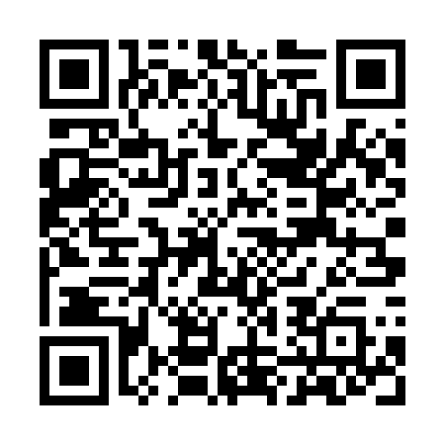
Prayer times for Longeville-les-Cheminot, France
Wed 1 May 2024 - Fri 31 May 2024
High Latitude Method: Angle Based Rule
Prayer Calculation Method: Islamic Organisations Union of France
Asar Calculation Method: Shafi

Date | Day | Fajr | Sunrise | Dhuhr | Asr | Maghrib | Isha
1 | Wed | 4:53 | 6:14 | 1:32 | 5:33 | 8:52 | 10:13
2 | Thu | 4:51 | 6:12 | 1:32 | 5:34 | 8:53 | 10:15
3 | Fri | 4:49 | 6:11 | 1:32 | 5:34 | 8:55 | 10:17
4 | Sat | 4:47 | 6:09 | 1:32 | 5:35 | 8:56 | 10:19
5 | Sun | 4:45 | 6:07 | 1:32 | 5:35 | 8:58 | 10:21
6 | Mon | 4:42 | 6:06 | 1:32 | 5:36 | 8:59 | 10:23
7 | Tue | 4:40 | 6:04 | 1:32 | 5:36 | 9:00 | 10:25
8 | Wed | 4:38 | 6:03 | 1:32 | 5:37 | 9:02 | 10:27
9 | Thu | 4:36 | 6:01 | 1:32 | 5:37 | 9:03 | 10:29
10 | Fri | 4:34 | 6:00 | 1:32 | 5:38 | 9:05 | 10:31
11 | Sat | 4:32 | 5:58 | 1:32 | 5:38 | 9:06 | 10:33
12 | Sun | 4:30 | 5:57 | 1:32 | 5:39 | 9:07 | 10:34
13 | Mon | 4:28 | 5:56 | 1:32 | 5:39 | 9:09 | 10:36
14 | Tue | 4:26 | 5:54 | 1:32 | 5:40 | 9:10 | 10:38
15 | Wed | 4:24 | 5:53 | 1:32 | 5:40 | 9:11 | 10:40
16 | Thu | 4:22 | 5:52 | 1:32 | 5:41 | 9:13 | 10:42
17 | Fri | 4:21 | 5:50 | 1:32 | 5:41 | 9:14 | 10:44
18 | Sat | 4:19 | 5:49 | 1:32 | 5:42 | 9:15 | 10:46
19 | Sun | 4:17 | 5:48 | 1:32 | 5:42 | 9:17 | 10:48
20 | Mon | 4:15 | 5:47 | 1:32 | 5:43 | 9:18 | 10:50
21 | Tue | 4:14 | 5:46 | 1:32 | 5:43 | 9:19 | 10:52
22 | Wed | 4:12 | 5:44 | 1:32 | 5:44 | 9:20 | 10:53
23 | Thu | 4:10 | 5:43 | 1:32 | 5:44 | 9:22 | 10:55
24 | Fri | 4:09 | 5:42 | 1:32 | 5:45 | 9:23 | 10:57
25 | Sat | 4:07 | 5:41 | 1:32 | 5:45 | 9:24 | 10:59
26 | Sun | 4:06 | 5:40 | 1:33 | 5:46 | 9:25 | 11:00
27 | Mon | 4:04 | 5:40 | 1:33 | 5:46 | 9:26 | 11:02
28 | Tue | 4:03 | 5:39 | 1:33 | 5:47 | 9:27 | 11:04
29 | Wed | 4:01 | 5:38 | 1:33 | 5:47 | 9:28 | 11:05
30 | Thu | 4:00 | 5:37 | 1:33 | 5:48 | 9:29 | 11:07
31 | Fri | 3:59 | 5:36 | 1:33 | 5:48 | 9:30 | 11:08
Prayer times provided by https://www.salahtimes.com

