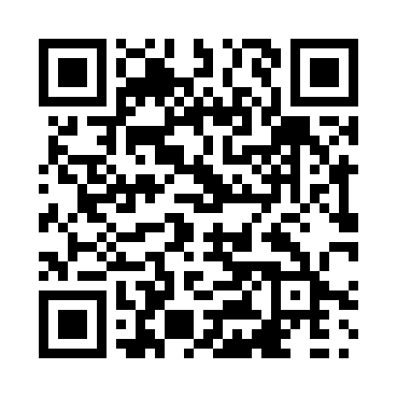

**Prayer times for Nunainnaq, Quebec, Canada**

**Sun 1 Sep 2024 - Mon 30 Sep 2024**

**High Latitude Method: Angle Based Rule**

**Prayer Calculation Method: Islamic Society of North America**

**Asar Calculation Method: Hanafi**

|  |  |  |  |  |  |  |  |
| --- | --- | --- | --- | --- | --- | --- | --- |
| **Date** | **Day** | **Fajr** | **Sunrise** | **Dhuhr** | **Asr** | **Maghrib** | **Isha** |
| 1 | Sun | 3:56 | 6:06 | 1:07 | 5:45 | 8:06 | 10:15 |
| 2 | Mon | 3:59 | 6:08 | 1:06 | 5:43 | 8:03 | 10:11 |
| 3 | Tue | 4:03 | 6:10 | 1:06 | 5:41 | 8:00 | 10:07 |
| 4 | Wed | 4:06 | 6:13 | 1:06 | 5:39 | 7:57 | 10:03 |
| 5 | Thu | 4:09 | 6:15 | 1:05 | 5:36 | 7:54 | 9:59 |
| 6 | Fri | 4:13 | 6:17 | 1:05 | 5:34 | 7:51 | 9:55 |
| 7 | Sat | 4:16 | 6:19 | 1:05 | 5:32 | 7:48 | 9:51 |
| 8 | Sun | 4:19 | 6:22 | 1:04 | 5:30 | 7:45 | 9:47 |
| 9 | Mon | 4:22 | 6:24 | 1:04 | 5:27 | 7:43 | 9:44 |
| 10 | Tue | 4:25 | 6:26 | 1:03 | 5:25 | 7:40 | 9:40 |
| 11 | Wed | 4:28 | 6:28 | 1:03 | 5:23 | 7:37 | 9:36 |
| 12 | Thu | 4:31 | 6:30 | 1:03 | 5:20 | 7:34 | 9:33 |
| 13 | Fri | 4:34 | 6:33 | 1:02 | 5:18 | 7:31 | 9:29 |
| 14 | Sat | 4:37 | 6:35 | 1:02 | 5:15 | 7:28 | 9:25 |
| 15 | Sun | 4:40 | 6:37 | 1:02 | 5:13 | 7:25 | 9:22 |
| 16 | Mon | 4:43 | 6:39 | 1:01 | 5:11 | 7:22 | 9:18 |
| 17 | Tue | 4:45 | 6:42 | 1:01 | 5:08 | 7:19 | 9:15 |
| 18 | Wed | 4:48 | 6:44 | 1:01 | 5:06 | 7:16 | 9:12 |
| 19 | Thu | 4:51 | 6:46 | 1:00 | 5:03 | 7:13 | 9:08 |
| 20 | Fri | 4:53 | 6:48 | 1:00 | 5:01 | 7:10 | 9:05 |
| 21 | Sat | 4:56 | 6:50 | 1:00 | 4:58 | 7:07 | 9:01 |
| 22 | Sun | 4:59 | 6:53 | 12:59 | 4:56 | 7:04 | 8:58 |
| 23 | Mon | 5:01 | 6:55 | 12:59 | 4:53 | 7:02 | 8:55 |
| 24 | Tue | 5:04 | 6:57 | 12:59 | 4:51 | 6:59 | 8:51 |
| 25 | Wed | 5:07 | 6:59 | 12:58 | 4:49 | 6:56 | 8:48 |
| 26 | Thu | 5:09 | 7:02 | 12:58 | 4:46 | 6:53 | 8:45 |
| 27 | Fri | 5:12 | 7:04 | 12:57 | 4:44 | 6:50 | 8:42 |
| 28 | Sat | 5:14 | 7:06 | 12:57 | 4:41 | 6:47 | 8:39 |
| 29 | Sun | 5:17 | 7:08 | 12:57 | 4:38 | 6:44 | 8:35 |
| 30 | Mon | 5:19 | 7:11 | 12:56 | 4:36 | 6:41 | 8:32 |

**Prayer times provided by https://www.salahtimes.com**