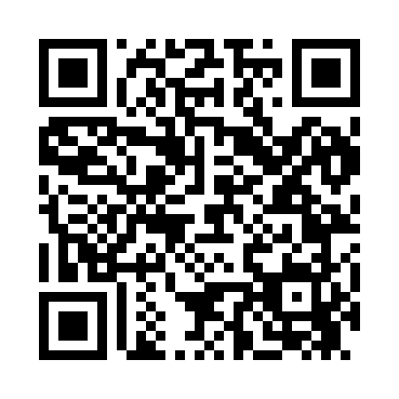
Prayer times for Alma Center, Wisconsin, USA
Wed 1 May 2024 - Fri 31 May 2024
High Latitude Method: Angle Based Rule
Prayer Calculation Method: Islamic Society of North America
Asar Calculation Method: Shafi

Date | Day | Fajr | Sunrise | Dhuhr | Asr | Maghrib | Isha
1 | Wed | 4:20 | 5:53 | 1:01 | 4:57 | 8:09 | 9:42
2 | Thu | 4:18 | 5:52 | 1:01 | 4:57 | 8:10 | 9:44
3 | Fri | 4:17 | 5:51 | 1:00 | 4:57 | 8:11 | 9:45
4 | Sat | 4:15 | 5:49 | 1:00 | 4:58 | 8:12 | 9:47
5 | Sun | 4:13 | 5:48 | 1:00 | 4:58 | 8:13 | 9:49
6 | Mon | 4:11 | 5:46 | 1:00 | 4:59 | 8:15 | 9:51
7 | Tue | 4:09 | 5:45 | 1:00 | 4:59 | 8:16 | 9:52
8 | Wed | 4:07 | 5:44 | 1:00 | 4:59 | 8:17 | 9:54
9 | Thu | 4:05 | 5:43 | 1:00 | 5:00 | 8:18 | 9:56
10 | Fri | 4:04 | 5:41 | 1:00 | 5:00 | 8:19 | 9:57
11 | Sat | 4:02 | 5:40 | 1:00 | 5:00 | 8:20 | 9:59
12 | Sun | 4:00 | 5:39 | 1:00 | 5:01 | 8:22 | 10:01
13 | Mon | 3:59 | 5:38 | 1:00 | 5:01 | 8:23 | 10:02
14 | Tue | 3:57 | 5:37 | 1:00 | 5:02 | 8:24 | 10:04
15 | Wed | 3:55 | 5:36 | 1:00 | 5:02 | 8:25 | 10:06
16 | Thu | 3:54 | 5:35 | 1:00 | 5:02 | 8:26 | 10:07
17 | Fri | 3:52 | 5:33 | 1:00 | 5:03 | 8:27 | 10:09
18 | Sat | 3:50 | 5:32 | 1:00 | 5:03 | 8:28 | 10:11
19 | Sun | 3:49 | 5:32 | 1:00 | 5:03 | 8:29 | 10:12
20 | Mon | 3:47 | 5:31 | 1:00 | 5:04 | 8:30 | 10:14
21 | Tue | 3:46 | 5:30 | 1:00 | 5:04 | 8:31 | 10:15
22 | Wed | 3:45 | 5:29 | 1:00 | 5:05 | 8:32 | 10:17
23 | Thu | 3:43 | 5:28 | 1:00 | 5:05 | 8:33 | 10:19
24 | Fri | 3:42 | 5:27 | 1:01 | 5:05 | 8:34 | 10:20
25 | Sat | 3:41 | 5:26 | 1:01 | 5:06 | 8:35 | 10:22
26 | Sun | 3:39 | 5:26 | 1:01 | 5:06 | 8:36 | 10:23
27 | Mon | 3:38 | 5:25 | 1:01 | 5:06 | 8:37 | 10:25
28 | Tue | 3:37 | 5:24 | 1:01 | 5:07 | 8:38 | 10:26
29 | Wed | 3:36 | 5:24 | 1:01 | 5:07 | 8:39 | 10:27
30 | Thu | 3:35 | 5:23 | 1:01 | 5:07 | 8:40 | 10:29
31 | Fri | 3:34 | 5:22 | 1:01 | 5:08 | 8:41 | 10:30
Prayer times provided by https://www.salahtimes.com

