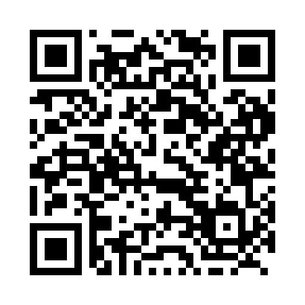

**Prayer times for Qimmitaarvik, Quebec, Canada**

**Sun 1 Sep 2024 - Mon 30 Sep 2024**

**High Latitude Method: Angle Based Rule**

**Prayer Calculation Method: Islamic Society of North America**

**Asar Calculation Method: Hanafi**

|  |  |  |  |  |  |  |  |
| --- | --- | --- | --- | --- | --- | --- | --- |
| **Date** | **Day** | **Fajr** | **Sunrise** | **Dhuhr** | **Asr** | **Maghrib** | **Isha** |
| 1 | Sun | 3:30 | 5:57 | 1:04 | 5:43 | 8:10 | 10:37 |
| 2 | Mon | 3:33 | 5:59 | 1:04 | 5:40 | 8:07 | 10:33 |
| 3 | Tue | 3:37 | 6:02 | 1:04 | 5:38 | 8:04 | 10:28 |
| 4 | Wed | 3:41 | 6:04 | 1:03 | 5:35 | 8:01 | 10:23 |
| 5 | Thu | 3:45 | 6:07 | 1:03 | 5:33 | 7:57 | 10:18 |
| 6 | Fri | 3:49 | 6:09 | 1:03 | 5:30 | 7:54 | 10:13 |
| 7 | Sat | 3:53 | 6:12 | 1:02 | 5:28 | 7:51 | 10:09 |
| 8 | Sun | 3:57 | 6:14 | 1:02 | 5:25 | 7:48 | 10:04 |
| 9 | Mon | 4:01 | 6:17 | 1:01 | 5:23 | 7:45 | 10:00 |
| 10 | Tue | 4:05 | 6:20 | 1:01 | 5:20 | 7:41 | 9:55 |
| 11 | Wed | 4:08 | 6:22 | 1:01 | 5:18 | 7:38 | 9:51 |
| 12 | Thu | 4:12 | 6:25 | 1:00 | 5:15 | 7:35 | 9:47 |
| 13 | Fri | 4:15 | 6:27 | 1:00 | 5:13 | 7:32 | 9:43 |
| 14 | Sat | 4:19 | 6:30 | 1:00 | 5:10 | 7:28 | 9:38 |
| 15 | Sun | 4:22 | 6:32 | 12:59 | 5:07 | 7:25 | 9:34 |
| 16 | Mon | 4:26 | 6:35 | 12:59 | 5:05 | 7:22 | 9:30 |
| 17 | Tue | 4:29 | 6:37 | 12:59 | 5:02 | 7:19 | 9:26 |
| 18 | Wed | 4:32 | 6:40 | 12:58 | 4:59 | 7:15 | 9:22 |
| 19 | Thu | 4:35 | 6:42 | 12:58 | 4:57 | 7:12 | 9:18 |
| 20 | Fri | 4:39 | 6:45 | 12:58 | 4:54 | 7:09 | 9:15 |
| 21 | Sat | 4:42 | 6:47 | 12:57 | 4:51 | 7:06 | 9:11 |
| 22 | Sun | 4:45 | 6:50 | 12:57 | 4:49 | 7:03 | 9:07 |
| 23 | Mon | 4:48 | 6:52 | 12:57 | 4:46 | 6:59 | 9:03 |
| 24 | Tue | 4:51 | 6:55 | 12:56 | 4:43 | 6:56 | 9:00 |
| 25 | Wed | 4:54 | 6:57 | 12:56 | 4:41 | 6:53 | 8:56 |
| 26 | Thu | 4:57 | 7:00 | 12:55 | 4:38 | 6:50 | 8:52 |
| 27 | Fri | 5:00 | 7:02 | 12:55 | 4:35 | 6:46 | 8:49 |
| 28 | Sat | 5:03 | 7:05 | 12:55 | 4:32 | 6:43 | 8:45 |
| 29 | Sun | 5:06 | 7:08 | 12:54 | 4:30 | 6:40 | 8:42 |
| 30 | Mon | 5:08 | 7:10 | 12:54 | 4:27 | 6:37 | 8:38 |

**Prayer times provided by https://www.salahtimes.com**