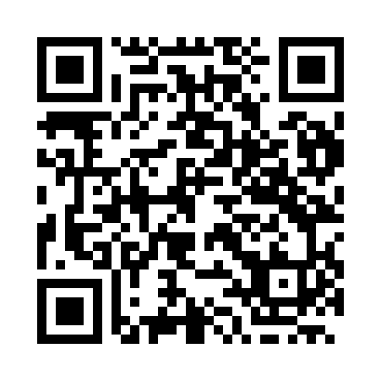
Prayer times for Novosibirsk, Russia
Wed 1 May 2024 - Fri 31 May 2024
High Latitude Method: Angle Based Rule
Prayer Calculation Method: Spiritual Administration of Muslims of Russia
Asar Calculation Method: Shafi

Date | Day | Fajr | Sunrise | Dhuhr | Asr | Maghrib | Isha
1 | Wed | 2:28 | 4:48 | 12:25 | 4:32 | 8:04 | 10:15
2 | Thu | 2:27 | 4:46 | 12:25 | 4:32 | 8:06 | 10:16
3 | Fri | 2:26 | 4:43 | 12:25 | 4:33 | 8:08 | 10:17
4 | Sat | 2:25 | 4:41 | 12:25 | 4:34 | 8:10 | 10:18
5 | Sun | 2:24 | 4:39 | 12:25 | 4:35 | 8:12 | 10:19
6 | Mon | 2:23 | 4:37 | 12:25 | 4:36 | 8:14 | 10:20
7 | Tue | 2:22 | 4:35 | 12:25 | 4:36 | 8:16 | 10:20
8 | Wed | 2:21 | 4:33 | 12:25 | 4:37 | 8:17 | 10:21
9 | Thu | 2:20 | 4:31 | 12:25 | 4:38 | 8:19 | 10:22
10 | Fri | 2:19 | 4:29 | 12:25 | 4:39 | 8:21 | 10:23
11 | Sat | 2:18 | 4:27 | 12:25 | 4:39 | 8:23 | 10:24
12 | Sun | 2:17 | 4:26 | 12:25 | 4:40 | 8:25 | 10:25
13 | Mon | 2:16 | 4:24 | 12:25 | 4:41 | 8:27 | 10:26
14 | Tue | 2:16 | 4:22 | 12:25 | 4:42 | 8:28 | 10:27
15 | Wed | 2:15 | 4:20 | 12:25 | 4:42 | 8:30 | 10:28
16 | Thu | 2:14 | 4:18 | 12:25 | 4:43 | 8:32 | 10:29
17 | Fri | 2:13 | 4:17 | 12:25 | 4:44 | 8:34 | 10:29
18 | Sat | 2:12 | 4:15 | 12:25 | 4:44 | 8:35 | 10:30
19 | Sun | 2:12 | 4:13 | 12:25 | 4:45 | 8:37 | 10:31
20 | Mon | 2:11 | 4:12 | 12:25 | 4:46 | 8:39 | 10:32
21 | Tue | 2:10 | 4:10 | 12:25 | 4:46 | 8:40 | 10:33
22 | Wed | 2:10 | 4:09 | 12:25 | 4:47 | 8:42 | 10:34
23 | Thu | 2:09 | 4:07 | 12:25 | 4:48 | 8:44 | 10:35
24 | Fri | 2:08 | 4:06 | 12:25 | 4:48 | 8:45 | 10:35
25 | Sat | 2:08 | 4:05 | 12:25 | 4:49 | 8:47 | 10:36
26 | Sun | 2:07 | 4:03 | 12:25 | 4:49 | 8:48 | 10:37
27 | Mon | 2:07 | 4:02 | 12:26 | 4:50 | 8:50 | 10:38
28 | Tue | 2:06 | 4:01 | 12:26 | 4:51 | 8:51 | 10:39
29 | Wed | 2:06 | 4:00 | 12:26 | 4:51 | 8:52 | 10:39
30 | Thu | 2:05 | 3:59 | 12:26 | 4:52 | 8:54 | 10:40
31 | Fri | 2:05 | 3:58 | 12:26 | 4:52 | 8:55 | 10:41
Prayer times provided by https://www.salahtimes.com

