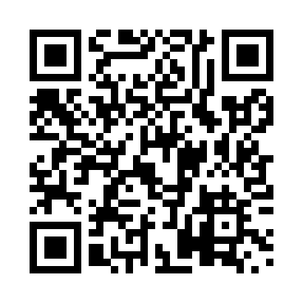

**Prayer times for Fort Nelson, British Columbia, Canada**

**Sun 1 Sep 2024 - Mon 30 Sep 2024**

**High Latitude Method: Angle Based Rule**

**Prayer Calculation Method: Islamic Society of North America**

**Asar Calculation Method: Hanafi**

|  |  |  |  |  |  |  |  |
| --- | --- | --- | --- | --- | --- | --- | --- |
| **Date** | **Day** | **Fajr** | **Sunrise** | **Dhuhr** | **Asr** | **Maghrib** | **Isha** |
| 1 | Sun | 4:01 | 6:11 | 1:11 | 5:49 | 8:09 | 10:18 |
| 2 | Mon | 4:05 | 6:13 | 1:10 | 5:47 | 8:06 | 10:14 |
| 3 | Tue | 4:08 | 6:15 | 1:10 | 5:45 | 8:04 | 10:10 |
| 4 | Wed | 4:11 | 6:17 | 1:10 | 5:42 | 8:01 | 10:06 |
| 5 | Thu | 4:14 | 6:19 | 1:09 | 5:40 | 7:58 | 10:02 |
| 6 | Fri | 4:18 | 6:22 | 1:09 | 5:38 | 7:55 | 9:58 |
| 7 | Sat | 4:21 | 6:24 | 1:09 | 5:36 | 7:52 | 9:54 |
| 8 | Sun | 4:24 | 6:26 | 1:08 | 5:33 | 7:49 | 9:51 |
| 9 | Mon | 4:27 | 6:28 | 1:08 | 5:31 | 7:46 | 9:47 |
| 10 | Tue | 4:30 | 6:30 | 1:07 | 5:29 | 7:43 | 9:43 |
| 11 | Wed | 4:33 | 6:33 | 1:07 | 5:26 | 7:40 | 9:40 |
| 12 | Thu | 4:36 | 6:35 | 1:07 | 5:24 | 7:37 | 9:36 |
| 13 | Fri | 4:39 | 6:37 | 1:06 | 5:22 | 7:34 | 9:32 |
| 14 | Sat | 4:42 | 6:39 | 1:06 | 5:19 | 7:32 | 9:29 |
| 15 | Sun | 4:44 | 6:42 | 1:06 | 5:17 | 7:29 | 9:25 |
| 16 | Mon | 4:47 | 6:44 | 1:05 | 5:14 | 7:26 | 9:22 |
| 17 | Tue | 4:50 | 6:46 | 1:05 | 5:12 | 7:23 | 9:18 |
| 18 | Wed | 4:53 | 6:48 | 1:05 | 5:10 | 7:20 | 9:15 |
| 19 | Thu | 4:55 | 6:50 | 1:04 | 5:07 | 7:17 | 9:11 |
| 20 | Fri | 4:58 | 6:53 | 1:04 | 5:05 | 7:14 | 9:08 |
| 21 | Sat | 5:01 | 6:55 | 1:04 | 5:02 | 7:11 | 9:05 |
| 22 | Sun | 5:03 | 6:57 | 1:03 | 5:00 | 7:08 | 9:01 |
| 23 | Mon | 5:06 | 6:59 | 1:03 | 4:57 | 7:05 | 8:58 |
| 24 | Tue | 5:09 | 7:01 | 1:03 | 4:55 | 7:02 | 8:55 |
| 25 | Wed | 5:11 | 7:04 | 1:02 | 4:52 | 6:59 | 8:52 |
| 26 | Thu | 5:14 | 7:06 | 1:02 | 4:50 | 6:56 | 8:48 |
| 27 | Fri | 5:16 | 7:08 | 1:01 | 4:47 | 6:54 | 8:45 |
| 28 | Sat | 5:19 | 7:10 | 1:01 | 4:45 | 6:51 | 8:42 |
| 29 | Sun | 5:21 | 7:13 | 1:01 | 4:42 | 6:48 | 8:39 |
| 30 | Mon | 5:24 | 7:15 | 1:00 | 4:40 | 6:45 | 8:36 |

**Prayer times provided by https://www.salahtimes.com**