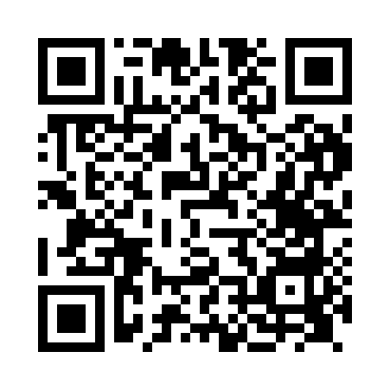

**Prayer times for Fodderty, Highland, UK**

**Sun 1 Sep 2024 - Mon 30 Sep 2024**

**High Latitude Method: Angle Based Rule**

**Prayer Calculation Method: Islamic Society of North America**

**Asar Calculation Method: Hanafi**

|  |  |  |  |  |  |  |  |
| --- | --- | --- | --- | --- | --- | --- | --- |
| **Date** | **Day** | **Fajr** | **Sunrise** | **Dhuhr** | **Asr** | **Maghrib** | **Isha** |
| 1 | Sun | 4:16 | 6:20 | 1:18 | 5:57 | 8:15 | 10:17 |
| 2 | Mon | 4:19 | 6:22 | 1:17 | 5:55 | 8:12 | 10:14 |
| 3 | Tue | 4:22 | 6:24 | 1:17 | 5:53 | 8:09 | 10:10 |
| 4 | Wed | 4:26 | 6:26 | 1:17 | 5:51 | 8:06 | 10:06 |
| 5 | Thu | 4:29 | 6:28 | 1:16 | 5:48 | 8:04 | 10:03 |
| 6 | Fri | 4:31 | 6:30 | 1:16 | 5:46 | 8:01 | 9:59 |
| 7 | Sat | 4:34 | 6:32 | 1:16 | 5:44 | 7:58 | 9:55 |
| 8 | Sun | 4:37 | 6:34 | 1:15 | 5:42 | 7:55 | 9:52 |
| 9 | Mon | 4:40 | 6:36 | 1:15 | 5:40 | 7:52 | 9:48 |
| 10 | Tue | 4:43 | 6:39 | 1:15 | 5:37 | 7:50 | 9:45 |
| 11 | Wed | 4:46 | 6:41 | 1:14 | 5:35 | 7:47 | 9:41 |
| 12 | Thu | 4:48 | 6:43 | 1:14 | 5:33 | 7:44 | 9:38 |
| 13 | Fri | 4:51 | 6:45 | 1:14 | 5:31 | 7:41 | 9:35 |
| 14 | Sat | 4:54 | 6:47 | 1:13 | 5:28 | 7:38 | 9:31 |
| 15 | Sun | 4:56 | 6:49 | 1:13 | 5:26 | 7:36 | 9:28 |
| 16 | Mon | 4:59 | 6:51 | 1:13 | 5:24 | 7:33 | 9:25 |
| 17 | Tue | 5:02 | 6:53 | 1:12 | 5:21 | 7:30 | 9:21 |
| 18 | Wed | 5:04 | 6:55 | 1:12 | 5:19 | 7:27 | 9:18 |
| 19 | Thu | 5:07 | 6:57 | 1:12 | 5:17 | 7:24 | 9:15 |
| 20 | Fri | 5:09 | 6:59 | 1:11 | 5:14 | 7:22 | 9:12 |
| 21 | Sat | 5:12 | 7:02 | 1:11 | 5:12 | 7:19 | 9:08 |
| 22 | Sun | 5:14 | 7:04 | 1:10 | 5:10 | 7:16 | 9:05 |
| 23 | Mon | 5:17 | 7:06 | 1:10 | 5:07 | 7:13 | 9:02 |
| 24 | Tue | 5:19 | 7:08 | 1:10 | 5:05 | 7:10 | 8:59 |
| 25 | Wed | 5:21 | 7:10 | 1:09 | 5:03 | 7:08 | 8:56 |
| 26 | Thu | 5:24 | 7:12 | 1:09 | 5:00 | 7:05 | 8:53 |
| 27 | Fri | 5:26 | 7:14 | 1:09 | 4:58 | 7:02 | 8:50 |
| 28 | Sat | 5:29 | 7:16 | 1:08 | 4:55 | 6:59 | 8:47 |
| 29 | Sun | 5:31 | 7:18 | 1:08 | 4:53 | 6:56 | 8:44 |
| 30 | Mon | 5:33 | 7:21 | 1:08 | 4:51 | 6:54 | 8:41 |

**Prayer times provided by https://www.salahtimes.com**