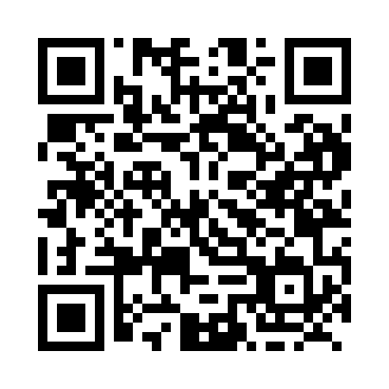
Prayer times for Cape Cove, Quebec, Canada
Mon 1 Apr 2024 - Tue 30 Apr 2024
High Latitude Method: Angle Based Rule
Prayer Calculation Method: Islamic Society of North America
Asar Calculation Method: Hanafi

Date | Day | Fajr | Sunrise | Dhuhr | Asr | Maghrib | Isha
1 | Mon | 4:25 | 5:54 | 12:21 | 4:50 | 6:49 | 8:18
2 | Tue | 4:22 | 5:52 | 12:21 | 4:51 | 6:50 | 8:20
3 | Wed | 4:20 | 5:50 | 12:20 | 4:52 | 6:52 | 8:22
4 | Thu | 4:18 | 5:48 | 12:20 | 4:53 | 6:53 | 8:24
5 | Fri | 4:15 | 5:46 | 12:20 | 4:54 | 6:55 | 8:26
6 | Sat | 4:13 | 5:44 | 12:20 | 4:55 | 6:56 | 8:27
7 | Sun | 4:10 | 5:42 | 12:19 | 4:56 | 6:57 | 8:29
8 | Mon | 4:08 | 5:40 | 12:19 | 4:57 | 6:59 | 8:31
9 | Tue | 4:06 | 5:38 | 12:19 | 4:58 | 7:00 | 8:33
10 | Wed | 4:03 | 5:36 | 12:18 | 4:59 | 7:02 | 8:35
11 | Thu | 4:01 | 5:34 | 12:18 | 5:00 | 7:03 | 8:37
12 | Fri | 3:58 | 5:32 | 12:18 | 5:01 | 7:05 | 8:39
13 | Sat | 3:56 | 5:30 | 12:18 | 5:02 | 7:06 | 8:41
14 | Sun | 3:54 | 5:28 | 12:17 | 5:03 | 7:08 | 8:42
15 | Mon | 3:51 | 5:26 | 12:17 | 5:04 | 7:09 | 8:44
16 | Tue | 3:49 | 5:24 | 12:17 | 5:05 | 7:11 | 8:46
17 | Wed | 3:46 | 5:22 | 12:17 | 5:06 | 7:12 | 8:48
18 | Thu | 3:44 | 5:20 | 12:17 | 5:07 | 7:14 | 8:50
19 | Fri | 3:42 | 5:18 | 12:16 | 5:08 | 7:15 | 8:52
20 | Sat | 3:39 | 5:17 | 12:16 | 5:08 | 7:16 | 8:54
21 | Sun | 3:37 | 5:15 | 12:16 | 5:09 | 7:18 | 8:56
22 | Mon | 3:34 | 5:13 | 12:16 | 5:10 | 7:19 | 8:58
23 | Tue | 3:32 | 5:11 | 12:16 | 5:11 | 7:21 | 9:00
24 | Wed | 3:29 | 5:09 | 12:15 | 5:12 | 7:22 | 9:03
25 | Thu | 3:27 | 5:07 | 12:15 | 5:13 | 7:24 | 9:05
26 | Fri | 3:25 | 5:06 | 12:15 | 5:14 | 7:25 | 9:07
27 | Sat | 3:22 | 5:04 | 12:15 | 5:15 | 7:27 | 9:09
28 | Sun | 3:20 | 5:02 | 12:15 | 5:16 | 7:28 | 9:11
29 | Mon | 3:17 | 5:00 | 12:15 | 5:17 | 7:30 | 9:13
30 | Tue | 3:15 | 4:59 | 12:14 | 5:18 | 7:31 | 9:15
Prayer times provided by https://www.salahtimes.com

