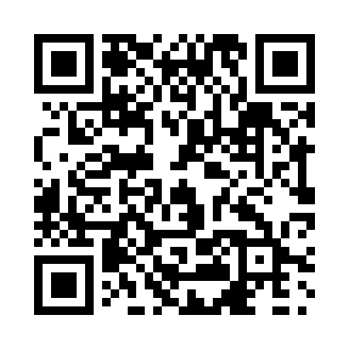
Prayer times for Behchoko, Northwest Territories, Canada
Wed 1 May 2024 - Fri 31 May 2024
High Latitude Method: Angle Based Rule
Prayer Calculation Method: Islamic Society of North America
Asar Calculation Method: Hanafi

Date | Day | Fajr | Sunrise | Dhuhr | Asr | Maghrib | Isha
1 | Wed | 3:33 | 5:23 | 1:41 | 7:04 | 10:01 | 11:51
2 | Thu | 3:31 | 5:20 | 1:41 | 7:05 | 10:04 | 11:53
3 | Fri | 3:29 | 5:17 | 1:41 | 7:07 | 10:07 | 11:54
4 | Sat | 3:28 | 5:14 | 1:41 | 7:09 | 10:10 | 11:56
5 | Sun | 3:26 | 5:11 | 1:41 | 7:10 | 10:13 | 11:57
6 | Mon | 3:24 | 5:07 | 1:41 | 7:12 | 10:16 | 11:59
7 | Tue | 3:23 | 5:04 | 1:41 | 7:13 | 10:19 | 12:00
8 | Wed | 3:21 | 5:01 | 1:41 | 7:15 | 10:22 | 12:02
9 | Thu | 3:20 | 4:58 | 1:41 | 7:16 | 10:25 | 12:03
10 | Fri | 3:18 | 4:55 | 1:41 | 7:18 | 10:27 | 12:04
11 | Sat | 3:17 | 4:52 | 1:41 | 7:19 | 10:30 | 12:06
12 | Sun | 3:15 | 4:49 | 1:41 | 7:21 | 10:33 | 12:07
13 | Mon | 3:14 | 4:46 | 1:41 | 7:22 | 10:36 | 12:09
14 | Tue | 3:12 | 4:44 | 1:41 | 7:24 | 10:39 | 12:10
15 | Wed | 3:11 | 4:41 | 1:41 | 7:25 | 10:42 | 12:12
16 | Thu | 3:10 | 4:38 | 1:41 | 7:27 | 10:45 | 12:13
17 | Fri | 3:08 | 4:35 | 1:41 | 7:28 | 10:48 | 12:15
18 | Sat | 3:07 | 4:32 | 1:41 | 7:29 | 10:51 | 12:16
19 | Sun | 3:05 | 4:30 | 1:41 | 7:31 | 10:53 | 12:17
20 | Mon | 3:04 | 4:27 | 1:41 | 7:32 | 10:56 | 12:19
21 | Tue | 3:03 | 4:24 | 1:41 | 7:33 | 10:59 | 12:20
22 | Wed | 3:02 | 4:22 | 1:41 | 7:34 | 11:02 | 12:22
23 | Thu | 3:00 | 4:19 | 1:41 | 7:36 | 11:04 | 12:23
24 | Fri | 2:59 | 4:17 | 1:41 | 7:37 | 11:07 | 12:24
25 | Sat | 2:58 | 4:14 | 1:41 | 7:38 | 11:10 | 12:26
26 | Sun | 2:57 | 4:12 | 1:41 | 7:39 | 11:12 | 12:27
27 | Mon | 2:56 | 4:09 | 1:42 | 7:40 | 11:15 | 12:29
28 | Tue | 2:55 | 4:07 | 1:42 | 7:41 | 11:17 | 12:30
29 | Wed | 2:54 | 4:05 | 1:42 | 7:42 | 11:20 | 12:31
30 | Thu | 2:53 | 4:03 | 1:42 | 7:43 | 11:22 | 12:32
31 | Fri | 2:52 | 4:01 | 1:42 | 7:44 | 11:25 | 12:34
Prayer times provided by https://www.salahtimes.com

