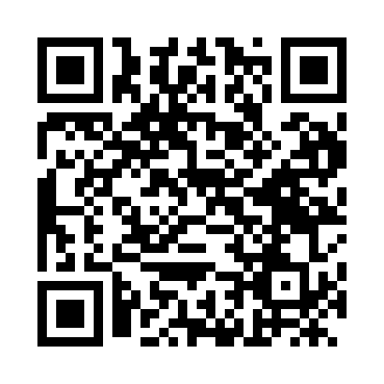
Prayer times for Trinidad, Cuba
Mon 1 Apr 2024 - Tue 30 Apr 2024
High Latitude Method: None
Prayer Calculation Method: Muslim World League
Asar Calculation Method: Shafi

Date | Day | Fajr | Sunrise | Dhuhr | Asr | Maghrib | Isha
1 | Mon | 5:57 | 7:12 | 1:24 | 4:49 | 7:35 | 8:46
2 | Tue | 5:56 | 7:11 | 1:23 | 4:49 | 7:36 | 8:46
3 | Wed | 5:55 | 7:10 | 1:23 | 4:49 | 7:36 | 8:47
4 | Thu | 5:54 | 7:10 | 1:23 | 4:48 | 7:36 | 8:47
5 | Fri | 5:53 | 7:09 | 1:22 | 4:48 | 7:37 | 8:47
6 | Sat | 5:52 | 7:08 | 1:22 | 4:48 | 7:37 | 8:48
7 | Sun | 5:51 | 7:07 | 1:22 | 4:47 | 7:37 | 8:48
8 | Mon | 5:50 | 7:06 | 1:22 | 4:47 | 7:38 | 8:49
9 | Tue | 5:49 | 7:05 | 1:21 | 4:47 | 7:38 | 8:49
10 | Wed | 5:48 | 7:04 | 1:21 | 4:46 | 7:38 | 8:50
11 | Thu | 5:47 | 7:03 | 1:21 | 4:46 | 7:39 | 8:50
12 | Fri | 5:46 | 7:03 | 1:21 | 4:46 | 7:39 | 8:51
13 | Sat | 5:45 | 7:02 | 1:20 | 4:45 | 7:39 | 8:51
14 | Sun | 5:44 | 7:01 | 1:20 | 4:45 | 7:40 | 8:52
15 | Mon | 5:43 | 7:00 | 1:20 | 4:45 | 7:40 | 8:52
16 | Tue | 5:42 | 6:59 | 1:20 | 4:44 | 7:40 | 8:53
17 | Wed | 5:41 | 6:58 | 1:19 | 4:44 | 7:41 | 8:53
18 | Thu | 5:41 | 6:58 | 1:19 | 4:43 | 7:41 | 8:54
19 | Fri | 5:40 | 6:57 | 1:19 | 4:43 | 7:41 | 8:54
20 | Sat | 5:39 | 6:56 | 1:19 | 4:43 | 7:42 | 8:55
21 | Sun | 5:38 | 6:55 | 1:19 | 4:42 | 7:42 | 8:55
22 | Mon | 5:37 | 6:54 | 1:18 | 4:42 | 7:43 | 8:56
23 | Tue | 5:36 | 6:54 | 1:18 | 4:42 | 7:43 | 8:56
24 | Wed | 5:35 | 6:53 | 1:18 | 4:41 | 7:43 | 8:57
25 | Thu | 5:34 | 6:52 | 1:18 | 4:41 | 7:44 | 8:57
26 | Fri | 5:33 | 6:51 | 1:18 | 4:41 | 7:44 | 8:58
27 | Sat | 5:32 | 6:51 | 1:17 | 4:40 | 7:44 | 8:58
28 | Sun | 5:31 | 6:50 | 1:17 | 4:40 | 7:45 | 8:59
29 | Mon | 5:31 | 6:49 | 1:17 | 4:39 | 7:45 | 9:00
30 | Tue | 5:30 | 6:49 | 1:17 | 4:39 | 7:46 | 9:00
Prayer times provided by https://www.salahtimes.com

