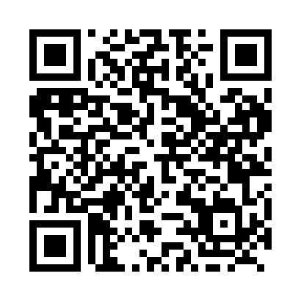

**Prayer times for Fireside, British Columbia, Canada**

**Sun 1 Sep 2024 - Mon 30 Sep 2024**

**High Latitude Method: Angle Based Rule**

**Prayer Calculation Method: Islamic Society of North America**

**Asar Calculation Method: Hanafi**

|  |  |  |  |  |  |  |  |
| --- | --- | --- | --- | --- | --- | --- | --- |
| **Date** | **Day** | **Fajr** | **Sunrise** | **Dhuhr** | **Asr** | **Maghrib** | **Isha** |
| 1 | Sun | 4:12 | 6:26 | 1:28 | 6:07 | 8:29 | 10:43 |
| 2 | Mon | 4:15 | 6:29 | 1:28 | 6:04 | 8:26 | 10:38 |
| 3 | Tue | 4:19 | 6:31 | 1:28 | 6:02 | 8:23 | 10:34 |
| 4 | Wed | 4:23 | 6:33 | 1:27 | 6:00 | 8:20 | 10:30 |
| 5 | Thu | 4:26 | 6:36 | 1:27 | 5:58 | 8:17 | 10:26 |
| 6 | Fri | 4:29 | 6:38 | 1:27 | 5:55 | 8:14 | 10:22 |
| 7 | Sat | 4:33 | 6:40 | 1:26 | 5:53 | 8:11 | 10:18 |
| 8 | Sun | 4:36 | 6:42 | 1:26 | 5:51 | 8:08 | 10:14 |
| 9 | Mon | 4:39 | 6:45 | 1:26 | 5:48 | 8:05 | 10:10 |
| 10 | Tue | 4:43 | 6:47 | 1:25 | 5:46 | 8:02 | 10:06 |
| 11 | Wed | 4:46 | 6:49 | 1:25 | 5:43 | 7:59 | 10:02 |
| 12 | Thu | 4:49 | 6:52 | 1:25 | 5:41 | 7:56 | 9:58 |
| 13 | Fri | 4:52 | 6:54 | 1:24 | 5:39 | 7:53 | 9:55 |
| 14 | Sat | 4:55 | 6:56 | 1:24 | 5:36 | 7:50 | 9:51 |
| 15 | Sun | 4:58 | 6:59 | 1:23 | 5:34 | 7:47 | 9:47 |
| 16 | Mon | 5:01 | 7:01 | 1:23 | 5:31 | 7:44 | 9:44 |
| 17 | Tue | 5:04 | 7:03 | 1:23 | 5:29 | 7:41 | 9:40 |
| 18 | Wed | 5:07 | 7:05 | 1:22 | 5:26 | 7:38 | 9:36 |
| 19 | Thu | 5:10 | 7:08 | 1:22 | 5:24 | 7:35 | 9:33 |
| 20 | Fri | 5:12 | 7:10 | 1:22 | 5:21 | 7:32 | 9:29 |
| 21 | Sat | 5:15 | 7:12 | 1:21 | 5:19 | 7:29 | 9:26 |
| 22 | Sun | 5:18 | 7:15 | 1:21 | 5:16 | 7:26 | 9:22 |
| 23 | Mon | 5:21 | 7:17 | 1:21 | 5:14 | 7:23 | 9:19 |
| 24 | Tue | 5:23 | 7:19 | 1:20 | 5:11 | 7:20 | 9:16 |
| 25 | Wed | 5:26 | 7:22 | 1:20 | 5:08 | 7:17 | 9:12 |
| 26 | Thu | 5:29 | 7:24 | 1:20 | 5:06 | 7:14 | 9:09 |
| 27 | Fri | 5:31 | 7:26 | 1:19 | 5:03 | 7:11 | 9:06 |
| 28 | Sat | 5:34 | 7:29 | 1:19 | 5:01 | 7:08 | 9:02 |
| 29 | Sun | 5:37 | 7:31 | 1:19 | 4:58 | 7:05 | 8:59 |
| 30 | Mon | 5:39 | 7:33 | 1:18 | 4:56 | 7:02 | 8:56 |

**Prayer times provided by https://www.salahtimes.com**