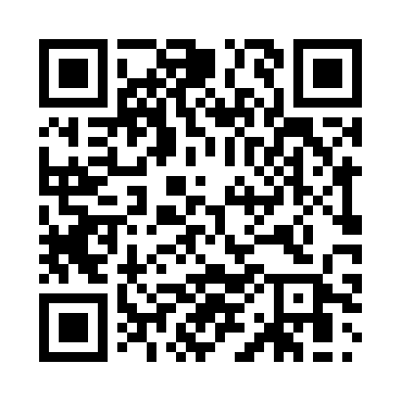
Prayer times for Unna, Germany
Wed 1 May 2024 - Fri 31 May 2024
High Latitude Method: Angle Based Rule
Prayer Calculation Method: Muslim World League
Asar Calculation Method: Shafi

Date | Day | Fajr | Sunrise | Dhuhr | Asr | Maghrib | Isha
1 | Wed | 3:30 | 6:00 | 1:26 | 5:29 | 8:53 | 11:12
2 | Thu | 3:27 | 5:58 | 1:26 | 5:30 | 8:55 | 11:15
3 | Fri | 3:23 | 5:57 | 1:26 | 5:31 | 8:57 | 11:19
4 | Sat | 3:19 | 5:55 | 1:26 | 5:31 | 8:58 | 11:22
5 | Sun | 3:15 | 5:53 | 1:26 | 5:32 | 9:00 | 11:25
6 | Mon | 3:12 | 5:51 | 1:26 | 5:33 | 9:01 | 11:28
7 | Tue | 3:11 | 5:49 | 1:26 | 5:33 | 9:03 | 11:32
8 | Wed | 3:11 | 5:48 | 1:26 | 5:34 | 9:05 | 11:33
9 | Thu | 3:10 | 5:46 | 1:26 | 5:34 | 9:06 | 11:33
10 | Fri | 3:09 | 5:44 | 1:26 | 5:35 | 9:08 | 11:34
11 | Sat | 3:09 | 5:43 | 1:26 | 5:36 | 9:09 | 11:35
12 | Sun | 3:08 | 5:41 | 1:26 | 5:36 | 9:11 | 11:35
13 | Mon | 3:07 | 5:40 | 1:26 | 5:37 | 9:12 | 11:36
14 | Tue | 3:07 | 5:38 | 1:26 | 5:38 | 9:14 | 11:37
15 | Wed | 3:06 | 5:37 | 1:26 | 5:38 | 9:15 | 11:37
16 | Thu | 3:06 | 5:35 | 1:26 | 5:39 | 9:17 | 11:38
17 | Fri | 3:05 | 5:34 | 1:26 | 5:39 | 9:18 | 11:39
18 | Sat | 3:05 | 5:32 | 1:26 | 5:40 | 9:20 | 11:39
19 | Sun | 3:04 | 5:31 | 1:26 | 5:40 | 9:21 | 11:40
20 | Mon | 3:04 | 5:30 | 1:26 | 5:41 | 9:23 | 11:41
21 | Tue | 3:03 | 5:28 | 1:26 | 5:42 | 9:24 | 11:41
22 | Wed | 3:03 | 5:27 | 1:26 | 5:42 | 9:25 | 11:42
23 | Thu | 3:02 | 5:26 | 1:26 | 5:43 | 9:27 | 11:43
24 | Fri | 3:02 | 5:25 | 1:26 | 5:43 | 9:28 | 11:43
25 | Sat | 3:01 | 5:24 | 1:26 | 5:44 | 9:29 | 11:44
26 | Sun | 3:01 | 5:23 | 1:26 | 5:44 | 9:31 | 11:44
27 | Mon | 3:01 | 5:22 | 1:26 | 5:45 | 9:32 | 11:45
28 | Tue | 3:00 | 5:21 | 1:27 | 5:45 | 9:33 | 11:46
29 | Wed | 3:00 | 5:20 | 1:27 | 5:46 | 9:34 | 11:46
30 | Thu | 3:00 | 5:19 | 1:27 | 5:46 | 9:35 | 11:47
31 | Fri | 3:00 | 5:18 | 1:27 | 5:47 | 9:36 | 11:47
Prayer times provided by https://www.salahtimes.com

