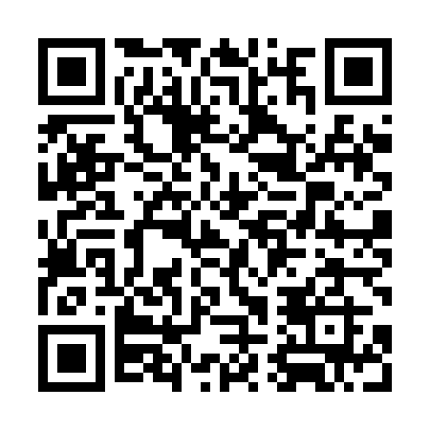
Prayer times for Polillo Island, Philippines
Mon 1 Apr 2024 - Tue 30 Apr 2024
High Latitude Method: None
Prayer Calculation Method: Muslim World League
Asar Calculation Method: Shafi

Date | Day | Fajr | Sunrise | Dhuhr | Asr | Maghrib | Isha
1 | Mon | 4:36 | 5:48 | 11:56 | 3:14 | 6:05 | 7:12
2 | Tue | 4:35 | 5:47 | 11:56 | 3:13 | 6:05 | 7:12
3 | Wed | 4:35 | 5:46 | 11:55 | 3:13 | 6:05 | 7:12
4 | Thu | 4:34 | 5:46 | 11:55 | 3:12 | 6:05 | 7:13
5 | Fri | 4:33 | 5:45 | 11:55 | 3:12 | 6:05 | 7:13
6 | Sat | 4:32 | 5:44 | 11:55 | 3:11 | 6:05 | 7:13
7 | Sun | 4:31 | 5:44 | 11:54 | 3:10 | 6:05 | 7:13
8 | Mon | 4:31 | 5:43 | 11:54 | 3:10 | 6:05 | 7:13
9 | Tue | 4:30 | 5:42 | 11:54 | 3:09 | 6:06 | 7:14
10 | Wed | 4:29 | 5:42 | 11:53 | 3:09 | 6:06 | 7:14
11 | Thu | 4:28 | 5:41 | 11:53 | 3:08 | 6:06 | 7:14
12 | Fri | 4:28 | 5:40 | 11:53 | 3:07 | 6:06 | 7:14
13 | Sat | 4:27 | 5:40 | 11:53 | 3:07 | 6:06 | 7:15
14 | Sun | 4:26 | 5:39 | 11:52 | 3:06 | 6:06 | 7:15
15 | Mon | 4:25 | 5:38 | 11:52 | 3:05 | 6:06 | 7:15
16 | Tue | 4:25 | 5:38 | 11:52 | 3:05 | 6:07 | 7:15
17 | Wed | 4:24 | 5:37 | 11:52 | 3:04 | 6:07 | 7:16
18 | Thu | 4:23 | 5:36 | 11:52 | 3:04 | 6:07 | 7:16
19 | Fri | 4:22 | 5:36 | 11:51 | 3:03 | 6:07 | 7:16
20 | Sat | 4:22 | 5:35 | 11:51 | 3:02 | 6:07 | 7:16
21 | Sun | 4:21 | 5:35 | 11:51 | 3:02 | 6:07 | 7:17
22 | Mon | 4:20 | 5:34 | 11:51 | 3:01 | 6:08 | 7:17
23 | Tue | 4:20 | 5:33 | 11:51 | 3:00 | 6:08 | 7:17
24 | Wed | 4:19 | 5:33 | 11:50 | 3:00 | 6:08 | 7:18
25 | Thu | 4:18 | 5:32 | 11:50 | 2:59 | 6:08 | 7:18
26 | Fri | 4:18 | 5:32 | 11:50 | 2:58 | 6:08 | 7:18
27 | Sat | 4:17 | 5:31 | 11:50 | 2:58 | 6:09 | 7:19
28 | Sun | 4:16 | 5:31 | 11:50 | 2:57 | 6:09 | 7:19
29 | Mon | 4:16 | 5:30 | 11:50 | 2:56 | 6:09 | 7:19
30 | Tue | 4:15 | 5:30 | 11:49 | 2:56 | 6:09 | 7:20
Prayer times provided by https://www.salahtimes.com

