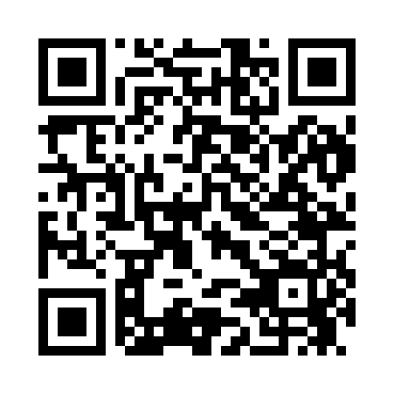
Prayer times for Belgrade Lakes, Maine, USA
Wed 1 May 2024 - Fri 31 May 2024
High Latitude Method: Angle Based Rule
Prayer Calculation Method: Islamic Society of North America
Asar Calculation Method: Shafi

Date | Day | Fajr | Sunrise | Dhuhr | Asr | Maghrib | Isha
1 | Wed | 3:56 | 5:29 | 12:37 | 4:32 | 7:45 | 9:18
2 | Thu | 3:54 | 5:28 | 12:36 | 4:33 | 7:46 | 9:20
3 | Fri | 3:52 | 5:26 | 12:36 | 4:33 | 7:47 | 9:22
4 | Sat | 3:50 | 5:25 | 12:36 | 4:34 | 7:48 | 9:23
5 | Sun | 3:48 | 5:24 | 12:36 | 4:34 | 7:50 | 9:25
6 | Mon | 3:46 | 5:22 | 12:36 | 4:35 | 7:51 | 9:27
7 | Tue | 3:45 | 5:21 | 12:36 | 4:35 | 7:52 | 9:29
8 | Wed | 3:43 | 5:20 | 12:36 | 4:35 | 7:53 | 9:30
9 | Thu | 3:41 | 5:18 | 12:36 | 4:36 | 7:54 | 9:32
10 | Fri | 3:39 | 5:17 | 12:36 | 4:36 | 7:55 | 9:34
11 | Sat | 3:37 | 5:16 | 12:36 | 4:36 | 7:57 | 9:35
12 | Sun | 3:36 | 5:15 | 12:36 | 4:37 | 7:58 | 9:37
13 | Mon | 3:34 | 5:14 | 12:36 | 4:37 | 7:59 | 9:39
14 | Tue | 3:32 | 5:12 | 12:36 | 4:38 | 8:00 | 9:40
15 | Wed | 3:31 | 5:11 | 12:36 | 4:38 | 8:01 | 9:42
16 | Thu | 3:29 | 5:10 | 12:36 | 4:38 | 8:02 | 9:44
17 | Fri | 3:27 | 5:09 | 12:36 | 4:39 | 8:03 | 9:45
18 | Sat | 3:26 | 5:08 | 12:36 | 4:39 | 8:04 | 9:47
19 | Sun | 3:24 | 5:07 | 12:36 | 4:39 | 8:05 | 9:49
20 | Mon | 3:23 | 5:06 | 12:36 | 4:40 | 8:07 | 9:50
21 | Tue | 3:21 | 5:05 | 12:36 | 4:40 | 8:08 | 9:52
22 | Wed | 3:20 | 5:04 | 12:36 | 4:41 | 8:09 | 9:53
23 | Thu | 3:19 | 5:04 | 12:36 | 4:41 | 8:10 | 9:55
24 | Fri | 3:17 | 5:03 | 12:36 | 4:41 | 8:11 | 9:57
25 | Sat | 3:16 | 5:02 | 12:37 | 4:42 | 8:12 | 9:58
26 | Sun | 3:15 | 5:01 | 12:37 | 4:42 | 8:13 | 10:00
27 | Mon | 3:13 | 5:01 | 12:37 | 4:42 | 8:13 | 10:01
28 | Tue | 3:12 | 5:00 | 12:37 | 4:43 | 8:14 | 10:02
29 | Wed | 3:11 | 4:59 | 12:37 | 4:43 | 8:15 | 10:04
30 | Thu | 3:10 | 4:59 | 12:37 | 4:43 | 8:16 | 10:05
31 | Fri | 3:09 | 4:58 | 12:37 | 4:44 | 8:17 | 10:06
Prayer times provided by https://www.salahtimes.com

