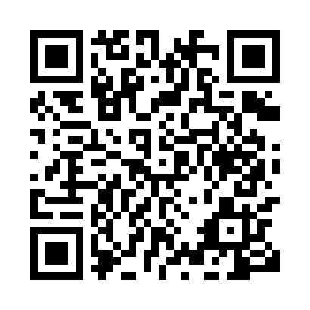
Prayer times for Bitsokmam, Cameroon
Wed 1 May 2024 - Fri 31 May 2024
High Latitude Method: None
Prayer Calculation Method: Muslim World League
Asar Calculation Method: Shafi

Date | Day | Fajr | Sunrise | Dhuhr | Asr | Maghrib | Isha
1 | Wed | 4:53 | 6:04 | 12:11 | 3:30 | 6:18 | 7:25
2 | Thu | 4:52 | 6:04 | 12:11 | 3:31 | 6:18 | 7:25
3 | Fri | 4:52 | 6:04 | 12:11 | 3:31 | 6:18 | 7:25
4 | Sat | 4:52 | 6:04 | 12:11 | 3:31 | 6:18 | 7:25
5 | Sun | 4:52 | 6:04 | 12:11 | 3:31 | 6:18 | 7:26
6 | Mon | 4:51 | 6:03 | 12:11 | 3:32 | 6:18 | 7:26
7 | Tue | 4:51 | 6:03 | 12:10 | 3:32 | 6:18 | 7:26
8 | Wed | 4:51 | 6:03 | 12:10 | 3:32 | 6:18 | 7:26
9 | Thu | 4:51 | 6:03 | 12:10 | 3:32 | 6:18 | 7:26
10 | Fri | 4:50 | 6:03 | 12:10 | 3:32 | 6:18 | 7:26
11 | Sat | 4:50 | 6:03 | 12:10 | 3:33 | 6:18 | 7:26
12 | Sun | 4:50 | 6:03 | 12:10 | 3:33 | 6:18 | 7:26
13 | Mon | 4:50 | 6:03 | 12:10 | 3:33 | 6:18 | 7:27
14 | Tue | 4:50 | 6:03 | 12:10 | 3:33 | 6:18 | 7:27
15 | Wed | 4:49 | 6:03 | 12:10 | 3:34 | 6:18 | 7:27
16 | Thu | 4:49 | 6:03 | 12:10 | 3:34 | 6:18 | 7:27
17 | Fri | 4:49 | 6:03 | 12:10 | 3:34 | 6:18 | 7:27
18 | Sat | 4:49 | 6:02 | 12:10 | 3:34 | 6:18 | 7:28
19 | Sun | 4:49 | 6:02 | 12:10 | 3:35 | 6:18 | 7:28
20 | Mon | 4:49 | 6:02 | 12:11 | 3:35 | 6:19 | 7:28
21 | Tue | 4:49 | 6:02 | 12:11 | 3:35 | 6:19 | 7:28
22 | Wed | 4:49 | 6:03 | 12:11 | 3:35 | 6:19 | 7:28
23 | Thu | 4:49 | 6:03 | 12:11 | 3:35 | 6:19 | 7:29
24 | Fri | 4:49 | 6:03 | 12:11 | 3:36 | 6:19 | 7:29
25 | Sat | 4:48 | 6:03 | 12:11 | 3:36 | 6:19 | 7:29
26 | Sun | 4:48 | 6:03 | 12:11 | 3:36 | 6:19 | 7:29
27 | Mon | 4:48 | 6:03 | 12:11 | 3:36 | 6:20 | 7:30
28 | Tue | 4:48 | 6:03 | 12:11 | 3:37 | 6:20 | 7:30
29 | Wed | 4:48 | 6:03 | 12:11 | 3:37 | 6:20 | 7:30
30 | Thu | 4:48 | 6:03 | 12:12 | 3:37 | 6:20 | 7:30
31 | Fri | 4:48 | 6:03 | 12:12 | 3:37 | 6:20 | 7:31
Prayer times provided by https://www.salahtimes.com

