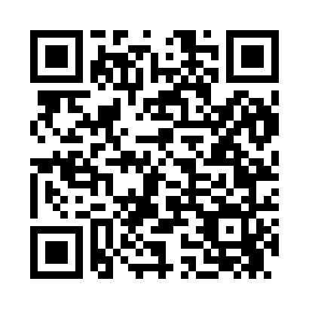
Prayer times for Alla, California, USA
Sat 1 Jun 2024 - Sun 30 Jun 2024
High Latitude Method: Angle Based Rule
Prayer Calculation Method: Islamic Society of North America
Asar Calculation Method: Shafi

Date | Day | Fajr | Sunrise | Dhuhr | Asr | Maghrib | Isha
1 | Sat | 4:21 | 5:43 | 12:52 | 4:37 | 8:00 | 9:23
2 | Sun | 4:20 | 5:43 | 12:52 | 4:37 | 8:01 | 9:24
3 | Mon | 4:20 | 5:43 | 12:52 | 4:37 | 8:01 | 9:24
4 | Tue | 4:20 | 5:43 | 12:52 | 4:37 | 8:02 | 9:25
5 | Wed | 4:19 | 5:43 | 12:52 | 4:38 | 8:02 | 9:26
6 | Thu | 4:19 | 5:42 | 12:53 | 4:38 | 8:03 | 9:26
7 | Fri | 4:19 | 5:42 | 12:53 | 4:38 | 8:03 | 9:27
8 | Sat | 4:19 | 5:42 | 12:53 | 4:38 | 8:04 | 9:28
9 | Sun | 4:18 | 5:42 | 12:53 | 4:38 | 8:04 | 9:28
10 | Mon | 4:18 | 5:42 | 12:53 | 4:39 | 8:05 | 9:29
11 | Tue | 4:18 | 5:42 | 12:54 | 4:39 | 8:05 | 9:29
12 | Wed | 4:18 | 5:42 | 12:54 | 4:39 | 8:06 | 9:30
13 | Thu | 4:18 | 5:42 | 12:54 | 4:39 | 8:06 | 9:30
14 | Fri | 4:18 | 5:42 | 12:54 | 4:39 | 8:06 | 9:31
15 | Sat | 4:18 | 5:42 | 12:54 | 4:40 | 8:07 | 9:31
16 | Sun | 4:18 | 5:42 | 12:55 | 4:40 | 8:07 | 9:31
17 | Mon | 4:18 | 5:42 | 12:55 | 4:40 | 8:07 | 9:32
18 | Tue | 4:18 | 5:43 | 12:55 | 4:40 | 8:08 | 9:32
19 | Wed | 4:18 | 5:43 | 12:55 | 4:40 | 8:08 | 9:32
20 | Thu | 4:19 | 5:43 | 12:56 | 4:41 | 8:08 | 9:32
21 | Fri | 4:19 | 5:43 | 12:56 | 4:41 | 8:08 | 9:33
22 | Sat | 4:19 | 5:43 | 12:56 | 4:41 | 8:08 | 9:33
23 | Sun | 4:19 | 5:44 | 12:56 | 4:41 | 8:09 | 9:33
24 | Mon | 4:20 | 5:44 | 12:56 | 4:42 | 8:09 | 9:33
25 | Tue | 4:20 | 5:44 | 12:57 | 4:42 | 8:09 | 9:33
26 | Wed | 4:20 | 5:45 | 12:57 | 4:42 | 8:09 | 9:33
27 | Thu | 4:21 | 5:45 | 12:57 | 4:42 | 8:09 | 9:33
28 | Fri | 4:21 | 5:45 | 12:57 | 4:42 | 8:09 | 9:33
29 | Sat | 4:22 | 5:46 | 12:57 | 4:43 | 8:09 | 9:33
30 | Sun | 4:22 | 5:46 | 12:58 | 4:43 | 8:09 | 9:33
Prayer times provided by https://www.salahtimes.com

