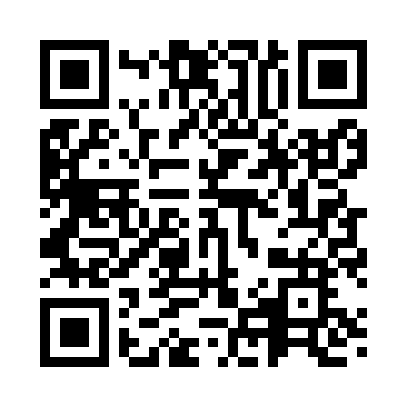

**Prayer times for Aburi, Estonia**

**Sun 1 Sep 2024 - Mon 30 Sep 2024**

**High Latitude Method: Angle Based Rule**

**Prayer Calculation Method: Muslim World League**

**Asar Calculation Method: Hanafi**

|  |  |  |  |  |  |  |  |
| --- | --- | --- | --- | --- | --- | --- | --- |
| **Date** | **Day** | **Fajr** | **Sunrise** | **Dhuhr** | **Asr** | **Maghrib** | **Isha** |
| 1 | Sun | 3:23 | 6:13 | 1:15 | 5:54 | 8:15 | 10:51 |
| 2 | Mon | 3:27 | 6:15 | 1:14 | 5:52 | 8:13 | 10:46 |
| 3 | Tue | 3:32 | 6:17 | 1:14 | 5:50 | 8:10 | 10:42 |
| 4 | Wed | 3:36 | 6:20 | 1:14 | 5:47 | 8:07 | 10:37 |
| 5 | Thu | 3:40 | 6:22 | 1:13 | 5:45 | 8:04 | 10:33 |
| 6 | Fri | 3:44 | 6:24 | 1:13 | 5:43 | 8:01 | 10:28 |
| 7 | Sat | 3:48 | 6:26 | 1:13 | 5:40 | 7:58 | 10:24 |
| 8 | Sun | 3:52 | 6:29 | 1:12 | 5:38 | 7:55 | 10:20 |
| 9 | Mon | 3:55 | 6:31 | 1:12 | 5:36 | 7:52 | 10:16 |
| 10 | Tue | 3:59 | 6:33 | 1:12 | 5:33 | 7:49 | 10:11 |
| 11 | Wed | 4:03 | 6:35 | 1:11 | 5:31 | 7:46 | 10:07 |
| 12 | Thu | 4:06 | 6:38 | 1:11 | 5:29 | 7:43 | 10:03 |
| 13 | Fri | 4:10 | 6:40 | 1:11 | 5:26 | 7:40 | 9:59 |
| 14 | Sat | 4:13 | 6:42 | 1:10 | 5:24 | 7:37 | 9:56 |
| 15 | Sun | 4:16 | 6:44 | 1:10 | 5:22 | 7:34 | 9:52 |
| 16 | Mon | 4:19 | 6:47 | 1:10 | 5:19 | 7:31 | 9:48 |
| 17 | Tue | 4:23 | 6:49 | 1:09 | 5:17 | 7:28 | 9:44 |
| 18 | Wed | 4:26 | 6:51 | 1:09 | 5:14 | 7:25 | 9:41 |
| 19 | Thu | 4:29 | 6:53 | 1:09 | 5:12 | 7:22 | 9:37 |
| 20 | Fri | 4:32 | 6:56 | 1:08 | 5:09 | 7:19 | 9:33 |
| 21 | Sat | 4:35 | 6:58 | 1:08 | 5:07 | 7:16 | 9:30 |
| 22 | Sun | 4:38 | 7:00 | 1:07 | 5:04 | 7:14 | 9:26 |
| 23 | Mon | 4:41 | 7:02 | 1:07 | 5:02 | 7:11 | 9:23 |
| 24 | Tue | 4:44 | 7:05 | 1:07 | 4:59 | 7:08 | 9:19 |
| 25 | Wed | 4:47 | 7:07 | 1:06 | 4:57 | 7:05 | 9:16 |
| 26 | Thu | 4:49 | 7:09 | 1:06 | 4:54 | 7:02 | 9:12 |
| 27 | Fri | 4:52 | 7:11 | 1:06 | 4:52 | 6:59 | 9:09 |
| 28 | Sat | 4:55 | 7:14 | 1:05 | 4:49 | 6:56 | 9:06 |
| 29 | Sun | 4:58 | 7:16 | 1:05 | 4:47 | 6:53 | 9:02 |
| 30 | Mon | 5:00 | 7:18 | 1:05 | 4:44 | 6:50 | 8:59 |

**Prayer times provided by https://www.salahtimes.com**