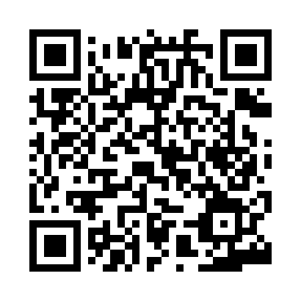

**Prayer times for Aby, Denmark**

**Sun 1 Sep 2024 - Mon 30 Sep 2024**

**High Latitude Method: Angle Based Rule**

**Prayer Calculation Method: Muslim World League**

**Asar Calculation Method: Hanafi**

|  |  |  |  |  |  |  |  |
| --- | --- | --- | --- | --- | --- | --- | --- |
| **Date** | **Day** | **Fajr** | **Sunrise** | **Dhuhr** | **Asr** | **Maghrib** | **Isha** |
| 1 | Sun | 3:50 | 6:24 | 1:21 | 6:00 | 8:17 | 10:39 |
| 2 | Mon | 3:53 | 6:26 | 1:21 | 5:58 | 8:14 | 10:35 |
| 3 | Tue | 3:57 | 6:28 | 1:20 | 5:56 | 8:11 | 10:31 |
| 4 | Wed | 4:00 | 6:30 | 1:20 | 5:54 | 8:09 | 10:27 |
| 5 | Thu | 4:04 | 6:32 | 1:20 | 5:52 | 8:06 | 10:23 |
| 6 | Fri | 4:07 | 6:34 | 1:19 | 5:50 | 8:03 | 10:19 |
| 7 | Sat | 4:10 | 6:36 | 1:19 | 5:47 | 8:01 | 10:15 |
| 8 | Sun | 4:14 | 6:38 | 1:19 | 5:45 | 7:58 | 10:12 |
| 9 | Mon | 4:17 | 6:40 | 1:18 | 5:43 | 7:55 | 10:08 |
| 10 | Tue | 4:20 | 6:42 | 1:18 | 5:41 | 7:52 | 10:04 |
| 11 | Wed | 4:23 | 6:44 | 1:17 | 5:39 | 7:50 | 10:01 |
| 12 | Thu | 4:26 | 6:46 | 1:17 | 5:36 | 7:47 | 9:57 |
| 13 | Fri | 4:29 | 6:48 | 1:17 | 5:34 | 7:44 | 9:54 |
| 14 | Sat | 4:32 | 6:50 | 1:16 | 5:32 | 7:41 | 9:50 |
| 15 | Sun | 4:35 | 6:52 | 1:16 | 5:30 | 7:39 | 9:47 |
| 16 | Mon | 4:37 | 6:54 | 1:16 | 5:27 | 7:36 | 9:43 |
| 17 | Tue | 4:40 | 6:56 | 1:15 | 5:25 | 7:33 | 9:40 |
| 18 | Wed | 4:43 | 6:59 | 1:15 | 5:23 | 7:30 | 9:37 |
| 19 | Thu | 4:46 | 7:01 | 1:15 | 5:21 | 7:27 | 9:33 |
| 20 | Fri | 4:48 | 7:03 | 1:14 | 5:18 | 7:25 | 9:30 |
| 21 | Sat | 4:51 | 7:05 | 1:14 | 5:16 | 7:22 | 9:27 |
| 22 | Sun | 4:54 | 7:07 | 1:14 | 5:14 | 7:19 | 9:23 |
| 23 | Mon | 4:56 | 7:09 | 1:13 | 5:11 | 7:16 | 9:20 |
| 24 | Tue | 4:59 | 7:11 | 1:13 | 5:09 | 7:14 | 9:17 |
| 25 | Wed | 5:01 | 7:13 | 1:12 | 5:06 | 7:11 | 9:14 |
| 26 | Thu | 5:04 | 7:15 | 1:12 | 5:04 | 7:08 | 9:11 |
| 27 | Fri | 5:06 | 7:17 | 1:12 | 5:02 | 7:05 | 9:08 |
| 28 | Sat | 5:09 | 7:19 | 1:11 | 4:59 | 7:03 | 9:05 |
| 29 | Sun | 5:11 | 7:21 | 1:11 | 4:57 | 7:00 | 9:02 |
| 30 | Mon | 5:14 | 7:23 | 1:11 | 4:55 | 6:57 | 8:59 |

**Prayer times provided by https://www.salahtimes.com**