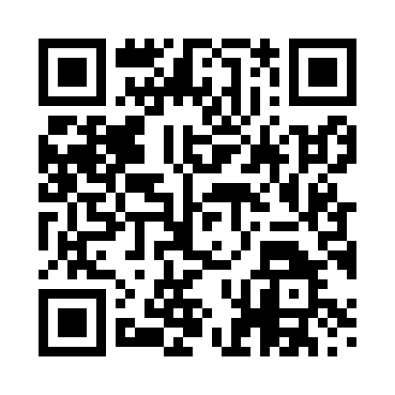

**Prayer times for Bejsnap, Denmark**

**Sun 1 Sep 2024 - Mon 30 Sep 2024**

**High Latitude Method: Angle Based Rule**

**Prayer Calculation Method: Muslim World League**

**Asar Calculation Method: Hanafi**

|  |  |  |  |  |  |  |  |
| --- | --- | --- | --- | --- | --- | --- | --- |
| **Date** | **Day** | **Fajr** | **Sunrise** | **Dhuhr** | **Asr** | **Maghrib** | **Isha** |
| 1 | Sun | 4:06 | 6:31 | 1:25 | 6:04 | 8:18 | 10:32 |
| 2 | Mon | 4:09 | 6:33 | 1:25 | 6:02 | 8:16 | 10:29 |
| 3 | Tue | 4:12 | 6:35 | 1:24 | 6:00 | 8:13 | 10:25 |
| 4 | Wed | 4:15 | 6:37 | 1:24 | 5:58 | 8:11 | 10:21 |
| 5 | Thu | 4:18 | 6:38 | 1:24 | 5:56 | 8:08 | 10:18 |
| 6 | Fri | 4:21 | 6:40 | 1:23 | 5:54 | 8:05 | 10:14 |
| 7 | Sat | 4:24 | 6:42 | 1:23 | 5:52 | 8:03 | 10:11 |
| 8 | Sun | 4:27 | 6:44 | 1:23 | 5:50 | 8:00 | 10:07 |
| 9 | Mon | 4:30 | 6:46 | 1:22 | 5:48 | 7:57 | 10:04 |
| 10 | Tue | 4:33 | 6:48 | 1:22 | 5:46 | 7:55 | 10:01 |
| 11 | Wed | 4:35 | 6:50 | 1:22 | 5:44 | 7:52 | 9:57 |
| 12 | Thu | 4:38 | 6:52 | 1:21 | 5:42 | 7:50 | 9:54 |
| 13 | Fri | 4:41 | 6:54 | 1:21 | 5:40 | 7:47 | 9:51 |
| 14 | Sat | 4:43 | 6:56 | 1:21 | 5:37 | 7:44 | 9:48 |
| 15 | Sun | 4:46 | 6:58 | 1:20 | 5:35 | 7:42 | 9:44 |
| 16 | Mon | 4:49 | 7:00 | 1:20 | 5:33 | 7:39 | 9:41 |
| 17 | Tue | 4:51 | 7:02 | 1:20 | 5:31 | 7:36 | 9:38 |
| 18 | Wed | 4:54 | 7:03 | 1:19 | 5:29 | 7:34 | 9:35 |
| 19 | Thu | 4:56 | 7:05 | 1:19 | 5:26 | 7:31 | 9:32 |
| 20 | Fri | 4:59 | 7:07 | 1:18 | 5:24 | 7:28 | 9:29 |
| 21 | Sat | 5:01 | 7:09 | 1:18 | 5:22 | 7:26 | 9:25 |
| 22 | Sun | 5:04 | 7:11 | 1:18 | 5:20 | 7:23 | 9:22 |
| 23 | Mon | 5:06 | 7:13 | 1:17 | 5:18 | 7:20 | 9:19 |
| 24 | Tue | 5:08 | 7:15 | 1:17 | 5:15 | 7:18 | 9:16 |
| 25 | Wed | 5:11 | 7:17 | 1:17 | 5:13 | 7:15 | 9:13 |
| 26 | Thu | 5:13 | 7:19 | 1:16 | 5:11 | 7:13 | 9:11 |
| 27 | Fri | 5:15 | 7:21 | 1:16 | 5:08 | 7:10 | 9:08 |
| 28 | Sat | 5:18 | 7:23 | 1:16 | 5:06 | 7:07 | 9:05 |
| 29 | Sun | 5:20 | 7:25 | 1:15 | 5:04 | 7:05 | 9:02 |
| 30 | Mon | 5:22 | 7:27 | 1:15 | 5:02 | 7:02 | 8:59 |

**Prayer times provided by https://www.salahtimes.com**