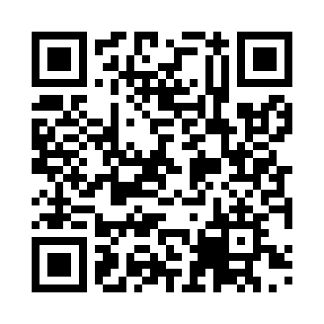
Prayer times for Namerikawa, Japan
Wed 1 May 2024 - Fri 31 May 2024
High Latitude Method: None
Prayer Calculation Method: Muslim World League
Asar Calculation Method: Shafi

Date | Day | Fajr | Sunrise | Dhuhr | Asr | Maghrib | Isha
1 | Wed | 3:20 | 4:57 | 11:48 | 3:34 | 6:39 | 8:10
2 | Thu | 3:19 | 4:56 | 11:48 | 3:34 | 6:40 | 8:11
3 | Fri | 3:17 | 4:55 | 11:48 | 3:34 | 6:41 | 8:13
4 | Sat | 3:16 | 4:54 | 11:47 | 3:35 | 6:42 | 8:14
5 | Sun | 3:14 | 4:53 | 11:47 | 3:35 | 6:43 | 8:15
6 | Mon | 3:13 | 4:51 | 11:47 | 3:35 | 6:44 | 8:16
7 | Tue | 3:11 | 4:50 | 11:47 | 3:35 | 6:44 | 8:17
8 | Wed | 3:10 | 4:49 | 11:47 | 3:35 | 6:45 | 8:19
9 | Thu | 3:09 | 4:49 | 11:47 | 3:35 | 6:46 | 8:20
10 | Fri | 3:07 | 4:48 | 11:47 | 3:35 | 6:47 | 8:21
11 | Sat | 3:06 | 4:47 | 11:47 | 3:36 | 6:48 | 8:22
12 | Sun | 3:05 | 4:46 | 11:47 | 3:36 | 6:49 | 8:24
13 | Mon | 3:03 | 4:45 | 11:47 | 3:36 | 6:50 | 8:25
14 | Tue | 3:02 | 4:44 | 11:47 | 3:36 | 6:50 | 8:26
15 | Wed | 3:01 | 4:43 | 11:47 | 3:36 | 6:51 | 8:27
16 | Thu | 3:00 | 4:42 | 11:47 | 3:36 | 6:52 | 8:28
17 | Fri | 2:58 | 4:42 | 11:47 | 3:37 | 6:53 | 8:30
18 | Sat | 2:57 | 4:41 | 11:47 | 3:37 | 6:54 | 8:31
19 | Sun | 2:56 | 4:40 | 11:47 | 3:37 | 6:55 | 8:32
20 | Mon | 2:55 | 4:39 | 11:47 | 3:37 | 6:55 | 8:33
21 | Tue | 2:54 | 4:39 | 11:47 | 3:37 | 6:56 | 8:34
22 | Wed | 2:53 | 4:38 | 11:47 | 3:38 | 6:57 | 8:35
23 | Thu | 2:52 | 4:38 | 11:47 | 3:38 | 6:58 | 8:36
24 | Fri | 2:51 | 4:37 | 11:48 | 3:38 | 6:58 | 8:38
25 | Sat | 2:50 | 4:36 | 11:48 | 3:38 | 6:59 | 8:39
26 | Sun | 2:49 | 4:36 | 11:48 | 3:38 | 7:00 | 8:40
27 | Mon | 2:48 | 4:35 | 11:48 | 3:39 | 7:01 | 8:41
28 | Tue | 2:48 | 4:35 | 11:48 | 3:39 | 7:01 | 8:42
29 | Wed | 2:47 | 4:34 | 11:48 | 3:39 | 7:02 | 8:43
30 | Thu | 2:46 | 4:34 | 11:48 | 3:39 | 7:03 | 8:44
31 | Fri | 2:45 | 4:34 | 11:48 | 3:39 | 7:03 | 8:45
Prayer times provided by https://www.salahtimes.com

