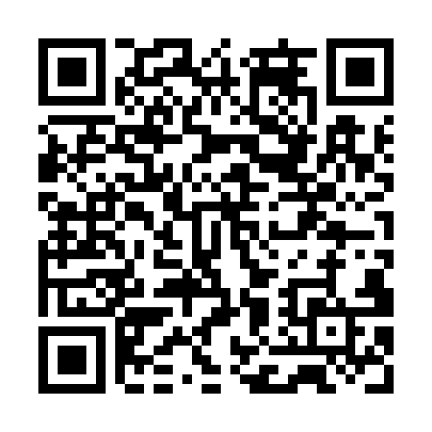
Prayer times for Palm Island, Australia
Wed 1 May 2024 - Fri 31 May 2024
High Latitude Method: None
Prayer Calculation Method: Muslim World League
Asar Calculation Method: Shafi

Date | Day | Fajr | Sunrise | Dhuhr | Asr | Maghrib | Isha
1 | Wed | 5:14 | 6:28 | 12:11 | 3:28 | 5:53 | 7:03
2 | Thu | 5:14 | 6:28 | 12:11 | 3:27 | 5:53 | 7:03
3 | Fri | 5:14 | 6:29 | 12:11 | 3:27 | 5:52 | 7:02
4 | Sat | 5:14 | 6:29 | 12:10 | 3:26 | 5:52 | 7:02
5 | Sun | 5:15 | 6:29 | 12:10 | 3:26 | 5:51 | 7:02
6 | Mon | 5:15 | 6:30 | 12:10 | 3:26 | 5:51 | 7:01
7 | Tue | 5:15 | 6:30 | 12:10 | 3:25 | 5:50 | 7:01
8 | Wed | 5:15 | 6:30 | 12:10 | 3:25 | 5:50 | 7:01
9 | Thu | 5:16 | 6:31 | 12:10 | 3:25 | 5:49 | 7:00
10 | Fri | 5:16 | 6:31 | 12:10 | 3:25 | 5:49 | 7:00
11 | Sat | 5:16 | 6:32 | 12:10 | 3:24 | 5:48 | 7:00
12 | Sun | 5:16 | 6:32 | 12:10 | 3:24 | 5:48 | 6:59
13 | Mon | 5:17 | 6:32 | 12:10 | 3:24 | 5:48 | 6:59
14 | Tue | 5:17 | 6:33 | 12:10 | 3:24 | 5:47 | 6:59
15 | Wed | 5:17 | 6:33 | 12:10 | 3:23 | 5:47 | 6:58
16 | Thu | 5:17 | 6:33 | 12:10 | 3:23 | 5:47 | 6:58
17 | Fri | 5:18 | 6:34 | 12:10 | 3:23 | 5:46 | 6:58
18 | Sat | 5:18 | 6:34 | 12:10 | 3:23 | 5:46 | 6:58
19 | Sun | 5:18 | 6:34 | 12:10 | 3:22 | 5:46 | 6:58
20 | Mon | 5:18 | 6:35 | 12:10 | 3:22 | 5:45 | 6:57
21 | Tue | 5:19 | 6:35 | 12:10 | 3:22 | 5:45 | 6:57
22 | Wed | 5:19 | 6:36 | 12:10 | 3:22 | 5:45 | 6:57
23 | Thu | 5:19 | 6:36 | 12:10 | 3:22 | 5:45 | 6:57
24 | Fri | 5:20 | 6:36 | 12:11 | 3:22 | 5:45 | 6:57
25 | Sat | 5:20 | 6:37 | 12:11 | 3:22 | 5:44 | 6:57
26 | Sun | 5:20 | 6:37 | 12:11 | 3:22 | 5:44 | 6:57
27 | Mon | 5:20 | 6:37 | 12:11 | 3:21 | 5:44 | 6:57
28 | Tue | 5:21 | 6:38 | 12:11 | 3:21 | 5:44 | 6:57
29 | Wed | 5:21 | 6:38 | 12:11 | 3:21 | 5:44 | 6:57
30 | Thu | 5:21 | 6:39 | 12:11 | 3:21 | 5:44 | 6:57
31 | Fri | 5:22 | 6:39 | 12:11 | 3:21 | 5:44 | 6:57
Prayer times provided by https://www.salahtimes.com

