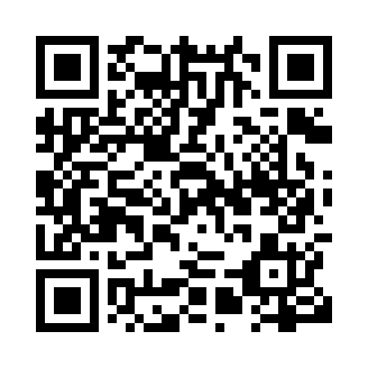

**Prayer times for Peoria, Alberta, Canada**

**Sun 1 Sep 2024 - Mon 30 Sep 2024**

**High Latitude Method: Angle Based Rule**

**Prayer Calculation Method: Islamic Society of North America**

**Asar Calculation Method: Hanafi**

|  |  |  |  |  |  |  |  |
| --- | --- | --- | --- | --- | --- | --- | --- |
| **Date** | **Day** | **Fajr** | **Sunrise** | **Dhuhr** | **Asr** | **Maghrib** | **Isha** |
| 1 | Sun | 5:06 | 7:00 | 1:53 | 6:32 | 8:45 | 10:39 |
| 2 | Mon | 5:08 | 7:02 | 1:53 | 6:30 | 8:43 | 10:35 |
| 3 | Tue | 5:11 | 7:04 | 1:52 | 6:28 | 8:40 | 10:32 |
| 4 | Wed | 5:14 | 7:06 | 1:52 | 6:26 | 8:37 | 10:29 |
| 5 | Thu | 5:16 | 7:07 | 1:52 | 6:24 | 8:35 | 10:26 |
| 6 | Fri | 5:19 | 7:09 | 1:51 | 6:22 | 8:32 | 10:22 |
| 7 | Sat | 5:21 | 7:11 | 1:51 | 6:20 | 8:30 | 10:19 |
| 8 | Sun | 5:24 | 7:13 | 1:51 | 6:18 | 8:27 | 10:16 |
| 9 | Mon | 5:26 | 7:15 | 1:50 | 6:15 | 8:24 | 10:13 |
| 10 | Tue | 5:29 | 7:17 | 1:50 | 6:13 | 8:22 | 10:10 |
| 11 | Wed | 5:31 | 7:19 | 1:50 | 6:11 | 8:19 | 10:06 |
| 12 | Thu | 5:34 | 7:21 | 1:49 | 6:09 | 8:17 | 10:03 |
| 13 | Fri | 5:36 | 7:23 | 1:49 | 6:07 | 8:14 | 10:00 |
| 14 | Sat | 5:38 | 7:25 | 1:49 | 6:05 | 8:11 | 9:57 |
| 15 | Sun | 5:41 | 7:27 | 1:48 | 6:03 | 8:09 | 9:54 |
| 16 | Mon | 5:43 | 7:28 | 1:48 | 6:00 | 8:06 | 9:51 |
| 17 | Tue | 5:45 | 7:30 | 1:47 | 5:58 | 8:03 | 9:48 |
| 18 | Wed | 5:48 | 7:32 | 1:47 | 5:56 | 8:01 | 9:45 |
| 19 | Thu | 5:50 | 7:34 | 1:47 | 5:54 | 7:58 | 9:42 |
| 20 | Fri | 5:52 | 7:36 | 1:46 | 5:52 | 7:55 | 9:39 |
| 21 | Sat | 5:54 | 7:38 | 1:46 | 5:49 | 7:53 | 9:36 |
| 22 | Sun | 5:57 | 7:40 | 1:46 | 5:47 | 7:50 | 9:33 |
| 23 | Mon | 5:59 | 7:42 | 1:45 | 5:45 | 7:48 | 9:30 |
| 24 | Tue | 6:01 | 7:44 | 1:45 | 5:43 | 7:45 | 9:28 |
| 25 | Wed | 6:03 | 7:46 | 1:45 | 5:41 | 7:42 | 9:25 |
| 26 | Thu | 6:05 | 7:48 | 1:44 | 5:38 | 7:40 | 9:22 |
| 27 | Fri | 6:08 | 7:50 | 1:44 | 5:36 | 7:37 | 9:19 |
| 28 | Sat | 6:10 | 7:52 | 1:44 | 5:34 | 7:35 | 9:16 |
| 29 | Sun | 6:12 | 7:54 | 1:43 | 5:31 | 7:32 | 9:14 |
| 30 | Mon | 6:14 | 7:55 | 1:43 | 5:29 | 7:29 | 9:11 |

**Prayer times provided by https://www.salahtimes.com**