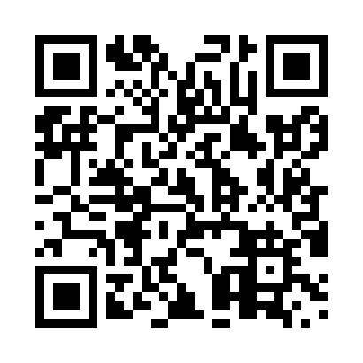

**Prayer times for Lester Beach, Manitoba, Canada**

**Sun 1 Dec 2024 - Tue 31 Dec 2024**

**High Latitude Method: Angle Based Rule**

**Prayer Calculation Method: Islamic Society of North America**

**Asar Calculation Method: Hanafi**

|  |  |  |  |  |  |  |  |
| --- | --- | --- | --- | --- | --- | --- | --- |
| **Date** | **Day** | **Fajr** | **Sunrise** | **Dhuhr** | **Asr** | **Maghrib** | **Isha** |
| 1 | Sun | 6:27 | 8:06 | 12:16 | 2:38 | 4:24 | 6:04 |
| 2 | Mon | 6:28 | 8:08 | 12:16 | 2:38 | 4:24 | 6:04 |
| 3 | Tue | 6:29 | 8:09 | 12:16 | 2:37 | 4:23 | 6:03 |
| 4 | Wed | 6:30 | 8:10 | 12:17 | 2:37 | 4:23 | 6:03 |
| 5 | Thu | 6:31 | 8:11 | 12:17 | 2:37 | 4:23 | 6:03 |
| 6 | Fri | 6:32 | 8:13 | 12:18 | 2:36 | 4:22 | 6:03 |
| 7 | Sat | 6:33 | 8:14 | 12:18 | 2:36 | 4:22 | 6:03 |
| 8 | Sun | 6:34 | 8:15 | 12:19 | 2:36 | 4:22 | 6:03 |
| 9 | Mon | 6:35 | 8:16 | 12:19 | 2:36 | 4:22 | 6:03 |
| 10 | Tue | 6:36 | 8:17 | 12:19 | 2:36 | 4:22 | 6:03 |
| 11 | Wed | 6:37 | 8:18 | 12:20 | 2:36 | 4:22 | 6:03 |
| 12 | Thu | 6:38 | 8:19 | 12:20 | 2:36 | 4:22 | 6:03 |
| 13 | Fri | 6:39 | 8:20 | 12:21 | 2:36 | 4:22 | 6:03 |
| 14 | Sat | 6:39 | 8:21 | 12:21 | 2:36 | 4:22 | 6:03 |
| 15 | Sun | 6:40 | 8:21 | 12:22 | 2:36 | 4:22 | 6:03 |
| 16 | Mon | 6:41 | 8:22 | 12:22 | 2:36 | 4:22 | 6:04 |
| 17 | Tue | 6:41 | 8:23 | 12:23 | 2:37 | 4:23 | 6:04 |
| 18 | Wed | 6:42 | 8:24 | 12:23 | 2:37 | 4:23 | 6:04 |
| 19 | Thu | 6:43 | 8:24 | 12:24 | 2:37 | 4:23 | 6:05 |
| 20 | Fri | 6:43 | 8:25 | 12:24 | 2:38 | 4:24 | 6:05 |
| 21 | Sat | 6:44 | 8:25 | 12:25 | 2:38 | 4:24 | 6:06 |
| 22 | Sun | 6:44 | 8:26 | 12:25 | 2:39 | 4:25 | 6:06 |
| 23 | Mon | 6:45 | 8:26 | 12:26 | 2:39 | 4:25 | 6:07 |
| 24 | Tue | 6:45 | 8:27 | 12:26 | 2:40 | 4:26 | 6:08 |
| 25 | Wed | 6:45 | 8:27 | 12:27 | 2:41 | 4:27 | 6:08 |
| 26 | Thu | 6:46 | 8:27 | 12:27 | 2:42 | 4:28 | 6:09 |
| 27 | Fri | 6:46 | 8:27 | 12:28 | 2:42 | 4:28 | 6:10 |
| 28 | Sat | 6:46 | 8:27 | 12:28 | 2:43 | 4:29 | 6:10 |
| 29 | Sun | 6:46 | 8:28 | 12:29 | 2:44 | 4:30 | 6:11 |
| 30 | Mon | 6:46 | 8:28 | 12:29 | 2:45 | 4:31 | 6:12 |
| 31 | Tue | 6:47 | 8:28 | 12:30 | 2:46 | 4:32 | 6:13 |

**Prayer times provided by https://www.salahtimes.com**