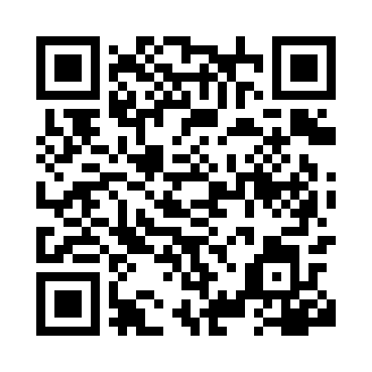

**Prayer times for Zelenodolsk, Russia**

**Sun 1 Dec 2024 - Tue 31 Dec 2024**

**High Latitude Method: Angle Based Rule**

**Prayer Calculation Method: Spiritual Administration of Muslims of Russia**

**Asar Calculation Method: Shafi**

|  |  |  |  |  |  |  |  |
| --- | --- | --- | --- | --- | --- | --- | --- |
| **Date** | **Day** | **Fajr** | **Sunrise** | **Dhuhr** | **Asr** | **Maghrib** | **Isha** |
| 1 | Sun | 5:49 | 7:52 | 11:35 | 1:01 | 3:17 | 5:13 |
| 2 | Mon | 5:51 | 7:54 | 11:35 | 1:01 | 3:17 | 5:13 |
| 3 | Tue | 5:52 | 7:55 | 11:36 | 1:01 | 3:16 | 5:12 |
| 4 | Wed | 5:53 | 7:57 | 11:36 | 1:00 | 3:15 | 5:12 |
| 5 | Thu | 5:54 | 7:58 | 11:37 | 1:00 | 3:14 | 5:11 |
| 6 | Fri | 5:55 | 8:00 | 11:37 | 12:59 | 3:14 | 5:11 |
| 7 | Sat | 5:56 | 8:01 | 11:38 | 12:59 | 3:13 | 5:11 |
| 8 | Sun | 5:57 | 8:03 | 11:38 | 12:59 | 3:13 | 5:11 |
| 9 | Mon | 5:59 | 8:04 | 11:38 | 12:59 | 3:13 | 5:10 |
| 10 | Tue | 6:00 | 8:05 | 11:39 | 12:59 | 3:12 | 5:10 |
| 11 | Wed | 6:01 | 8:06 | 11:39 | 12:59 | 3:12 | 5:10 |
| 12 | Thu | 6:01 | 8:07 | 11:40 | 12:59 | 3:12 | 5:10 |
| 13 | Fri | 6:02 | 8:08 | 11:40 | 12:59 | 3:12 | 5:10 |
| 14 | Sat | 6:03 | 8:09 | 11:41 | 12:59 | 3:12 | 5:11 |
| 15 | Sun | 6:04 | 8:10 | 11:41 | 12:59 | 3:12 | 5:11 |
| 16 | Mon | 6:05 | 8:11 | 11:42 | 12:59 | 3:12 | 5:11 |
| 17 | Tue | 6:05 | 8:12 | 11:42 | 1:00 | 3:12 | 5:11 |
| 18 | Wed | 6:06 | 8:13 | 11:43 | 1:00 | 3:12 | 5:12 |
| 19 | Thu | 6:07 | 8:13 | 11:43 | 1:00 | 3:13 | 5:12 |
| 20 | Fri | 6:07 | 8:14 | 11:44 | 1:01 | 3:13 | 5:12 |
| 21 | Sat | 6:08 | 8:15 | 11:44 | 1:01 | 3:14 | 5:13 |
| 22 | Sun | 6:08 | 8:15 | 11:45 | 1:02 | 3:14 | 5:13 |
| 23 | Mon | 6:09 | 8:16 | 11:45 | 1:02 | 3:15 | 5:14 |
| 24 | Tue | 6:09 | 8:16 | 11:46 | 1:03 | 3:16 | 5:15 |
| 25 | Wed | 6:10 | 8:16 | 11:46 | 1:04 | 3:16 | 5:15 |
| 26 | Thu | 6:10 | 8:16 | 11:47 | 1:04 | 3:17 | 5:16 |
| 27 | Fri | 6:10 | 8:16 | 11:47 | 1:05 | 3:18 | 5:17 |
| 28 | Sat | 6:10 | 8:17 | 11:48 | 1:06 | 3:19 | 5:18 |
| 29 | Sun | 6:10 | 8:17 | 11:48 | 1:07 | 3:20 | 5:18 |
| 30 | Mon | 6:11 | 8:16 | 11:49 | 1:08 | 3:21 | 5:19 |
| 31 | Tue | 6:11 | 8:16 | 11:49 | 1:09 | 3:22 | 5:20 |

**Prayer times provided by https://www.salahtimes.com**