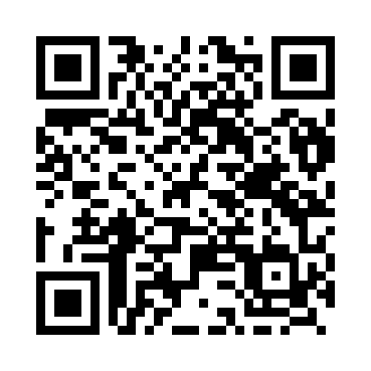

**Prayer times for Zviedri, Latvia**

**Sun 1 Sep 2024 - Mon 30 Sep 2024**

**High Latitude Method: Angle Based Rule**

**Prayer Calculation Method: Muslim World League**

**Asar Calculation Method: Hanafi**

|  |  |  |  |  |  |  |  |
| --- | --- | --- | --- | --- | --- | --- | --- |
| **Date** | **Day** | **Fajr** | **Sunrise** | **Dhuhr** | **Asr** | **Maghrib** | **Isha** |
| 1 | Sun | 3:42 | 6:15 | 1:12 | 5:52 | 8:08 | 10:29 |
| 2 | Mon | 3:46 | 6:17 | 1:12 | 5:50 | 8:06 | 10:25 |
| 3 | Tue | 3:49 | 6:19 | 1:12 | 5:48 | 8:03 | 10:22 |
| 4 | Wed | 3:53 | 6:21 | 1:11 | 5:46 | 8:00 | 10:18 |
| 5 | Thu | 3:56 | 6:23 | 1:11 | 5:43 | 7:58 | 10:14 |
| 6 | Fri | 3:59 | 6:26 | 1:11 | 5:41 | 7:55 | 10:10 |
| 7 | Sat | 4:03 | 6:28 | 1:10 | 5:39 | 7:52 | 10:06 |
| 8 | Sun | 4:06 | 6:30 | 1:10 | 5:37 | 7:49 | 10:03 |
| 9 | Mon | 4:09 | 6:32 | 1:10 | 5:35 | 7:47 | 9:59 |
| 10 | Tue | 4:12 | 6:34 | 1:09 | 5:33 | 7:44 | 9:55 |
| 11 | Wed | 4:15 | 6:36 | 1:09 | 5:30 | 7:41 | 9:52 |
| 12 | Thu | 4:18 | 6:38 | 1:09 | 5:28 | 7:38 | 9:48 |
| 13 | Fri | 4:21 | 6:40 | 1:08 | 5:26 | 7:36 | 9:45 |
| 14 | Sat | 4:24 | 6:42 | 1:08 | 5:24 | 7:33 | 9:41 |
| 15 | Sun | 4:27 | 6:44 | 1:08 | 5:21 | 7:30 | 9:38 |
| 16 | Mon | 4:29 | 6:46 | 1:07 | 5:19 | 7:27 | 9:34 |
| 17 | Tue | 4:32 | 6:48 | 1:07 | 5:17 | 7:25 | 9:31 |
| 18 | Wed | 4:35 | 6:50 | 1:07 | 5:15 | 7:22 | 9:28 |
| 19 | Thu | 4:38 | 6:52 | 1:06 | 5:12 | 7:19 | 9:24 |
| 20 | Fri | 4:40 | 6:54 | 1:06 | 5:10 | 7:16 | 9:21 |
| 21 | Sat | 4:43 | 6:56 | 1:05 | 5:08 | 7:14 | 9:18 |
| 22 | Sun | 4:45 | 6:58 | 1:05 | 5:05 | 7:11 | 9:15 |
| 23 | Mon | 4:48 | 7:00 | 1:05 | 5:03 | 7:08 | 9:12 |
| 24 | Tue | 4:51 | 7:02 | 1:04 | 5:01 | 7:05 | 9:08 |
| 25 | Wed | 4:53 | 7:04 | 1:04 | 4:58 | 7:03 | 9:05 |
| 26 | Thu | 4:56 | 7:06 | 1:04 | 4:56 | 7:00 | 9:02 |
| 27 | Fri | 4:58 | 7:08 | 1:03 | 4:54 | 6:57 | 8:59 |
| 28 | Sat | 5:00 | 7:11 | 1:03 | 4:51 | 6:54 | 8:56 |
| 29 | Sun | 5:03 | 7:13 | 1:03 | 4:49 | 6:52 | 8:53 |
| 30 | Mon | 5:05 | 7:15 | 1:02 | 4:46 | 6:49 | 8:50 |

**Prayer times provided by https://www.salahtimes.com**