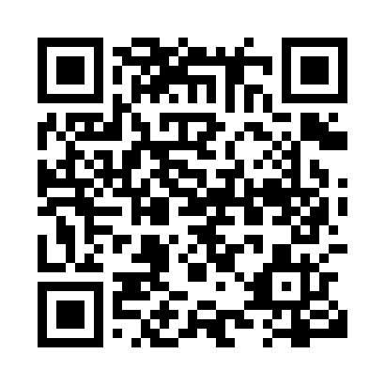

**Prayer times for Qajakkuvik, Quebec, Canada**

**Sun 1 Sep 2024 - Mon 30 Sep 2024**

**High Latitude Method: Angle Based Rule**

**Prayer Calculation Method: Islamic Society of North America**

**Asar Calculation Method: Hanafi**

|  |  |  |  |  |  |  |  |
| --- | --- | --- | --- | --- | --- | --- | --- |
| **Date** | **Day** | **Fajr** | **Sunrise** | **Dhuhr** | **Asr** | **Maghrib** | **Isha** |
| 1 | Sun | 3:19 | 5:35 | 12:38 | 5:17 | 7:40 | 9:55 |
| 2 | Mon | 3:23 | 5:38 | 12:38 | 5:15 | 7:37 | 9:51 |
| 3 | Tue | 3:27 | 5:40 | 12:38 | 5:13 | 7:34 | 9:47 |
| 4 | Wed | 3:30 | 5:42 | 12:37 | 5:10 | 7:31 | 9:43 |
| 5 | Thu | 3:34 | 5:45 | 12:37 | 5:08 | 7:28 | 9:38 |
| 6 | Fri | 3:37 | 5:47 | 12:37 | 5:06 | 7:25 | 9:34 |
| 7 | Sat | 3:41 | 5:49 | 12:36 | 5:03 | 7:22 | 9:30 |
| 8 | Sun | 3:44 | 5:52 | 12:36 | 5:01 | 7:19 | 9:26 |
| 9 | Mon | 3:47 | 5:54 | 12:36 | 4:58 | 7:16 | 9:22 |
| 10 | Tue | 3:51 | 5:56 | 12:35 | 4:56 | 7:13 | 9:18 |
| 11 | Wed | 3:54 | 5:59 | 12:35 | 4:54 | 7:10 | 9:14 |
| 12 | Thu | 3:57 | 6:01 | 12:35 | 4:51 | 7:07 | 9:10 |
| 13 | Fri | 4:00 | 6:03 | 12:34 | 4:49 | 7:04 | 9:07 |
| 14 | Sat | 4:03 | 6:06 | 12:34 | 4:46 | 7:01 | 9:03 |
| 15 | Sun | 4:06 | 6:08 | 12:34 | 4:44 | 6:58 | 8:59 |
| 16 | Mon | 4:09 | 6:10 | 12:33 | 4:41 | 6:55 | 8:55 |
| 17 | Tue | 4:12 | 6:13 | 12:33 | 4:39 | 6:52 | 8:52 |
| 18 | Wed | 4:15 | 6:15 | 12:33 | 4:36 | 6:49 | 8:48 |
| 19 | Thu | 4:18 | 6:17 | 12:32 | 4:34 | 6:46 | 8:45 |
| 20 | Fri | 4:21 | 6:20 | 12:32 | 4:31 | 6:43 | 8:41 |
| 21 | Sat | 4:24 | 6:22 | 12:32 | 4:29 | 6:40 | 8:37 |
| 22 | Sun | 4:27 | 6:24 | 12:31 | 4:26 | 6:37 | 8:34 |
| 23 | Mon | 4:29 | 6:27 | 12:31 | 4:24 | 6:34 | 8:31 |
| 24 | Tue | 4:32 | 6:29 | 12:30 | 4:21 | 6:31 | 8:27 |
| 25 | Wed | 4:35 | 6:31 | 12:30 | 4:18 | 6:27 | 8:24 |
| 26 | Thu | 4:38 | 6:34 | 12:30 | 4:16 | 6:24 | 8:20 |
| 27 | Fri | 4:40 | 6:36 | 12:29 | 4:13 | 6:21 | 8:17 |
| 28 | Sat | 4:43 | 6:38 | 12:29 | 4:11 | 6:18 | 8:14 |
| 29 | Sun | 4:45 | 6:41 | 12:29 | 4:08 | 6:15 | 8:10 |
| 30 | Mon | 4:48 | 6:43 | 12:28 | 4:06 | 6:12 | 8:07 |

**Prayer times provided by https://www.salahtimes.com**