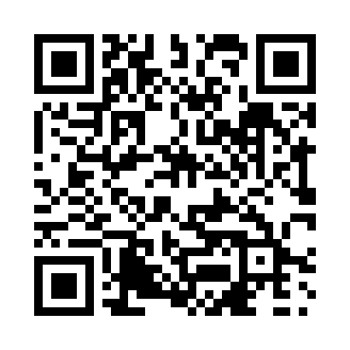
Prayer times for Union Bay, British Columbia, Canada
Wed 1 May 2024 - Fri 31 May 2024
High Latitude Method: Angle Based Rule
Prayer Calculation Method: Islamic Society of North America
Asar Calculation Method: Hanafi

Date | Day | Fajr | Sunrise | Dhuhr | Asr | Maghrib | Isha
1 | Wed | 4:07 | 5:56 | 1:17 | 6:22 | 8:38 | 10:27
2 | Thu | 4:05 | 5:54 | 1:16 | 6:23 | 8:40 | 10:30
3 | Fri | 4:02 | 5:52 | 1:16 | 6:24 | 8:41 | 10:32
4 | Sat | 3:59 | 5:51 | 1:16 | 6:25 | 8:43 | 10:34
5 | Sun | 3:57 | 5:49 | 1:16 | 6:26 | 8:44 | 10:37
6 | Mon | 3:54 | 5:47 | 1:16 | 6:27 | 8:46 | 10:39
7 | Tue | 3:52 | 5:46 | 1:16 | 6:27 | 8:47 | 10:42
8 | Wed | 3:49 | 5:44 | 1:16 | 6:28 | 8:49 | 10:44
9 | Thu | 3:47 | 5:43 | 1:16 | 6:29 | 8:50 | 10:46
10 | Fri | 3:44 | 5:41 | 1:16 | 6:30 | 8:51 | 10:49
11 | Sat | 3:42 | 5:40 | 1:16 | 6:31 | 8:53 | 10:51
12 | Sun | 3:40 | 5:38 | 1:16 | 6:32 | 8:54 | 10:54
13 | Mon | 3:37 | 5:37 | 1:16 | 6:33 | 8:56 | 10:56
14 | Tue | 3:35 | 5:35 | 1:16 | 6:33 | 8:57 | 10:58
15 | Wed | 3:32 | 5:34 | 1:16 | 6:34 | 8:58 | 11:01
16 | Thu | 3:30 | 5:33 | 1:16 | 6:35 | 9:00 | 11:03
17 | Fri | 3:28 | 5:32 | 1:16 | 6:36 | 9:01 | 11:06
18 | Sat | 3:25 | 5:30 | 1:16 | 6:37 | 9:02 | 11:08
19 | Sun | 3:23 | 5:29 | 1:16 | 6:37 | 9:04 | 11:10
20 | Mon | 3:22 | 5:28 | 1:16 | 6:38 | 9:05 | 11:11
21 | Tue | 3:22 | 5:27 | 1:16 | 6:39 | 9:06 | 11:11
22 | Wed | 3:21 | 5:26 | 1:16 | 6:40 | 9:08 | 11:12
23 | Thu | 3:21 | 5:25 | 1:16 | 6:40 | 9:09 | 11:13
24 | Fri | 3:20 | 5:24 | 1:16 | 6:41 | 9:10 | 11:13
25 | Sat | 3:20 | 5:23 | 1:17 | 6:42 | 9:11 | 11:14
26 | Sun | 3:19 | 5:22 | 1:17 | 6:42 | 9:12 | 11:15
27 | Mon | 3:19 | 5:21 | 1:17 | 6:43 | 9:13 | 11:15
28 | Tue | 3:18 | 5:20 | 1:17 | 6:44 | 9:15 | 11:16
29 | Wed | 3:18 | 5:19 | 1:17 | 6:44 | 9:16 | 11:16
30 | Thu | 3:18 | 5:18 | 1:17 | 6:45 | 9:17 | 11:17
31 | Fri | 3:18 | 5:17 | 1:17 | 6:46 | 9:18 | 11:18
Prayer times provided by https://www.salahtimes.com

