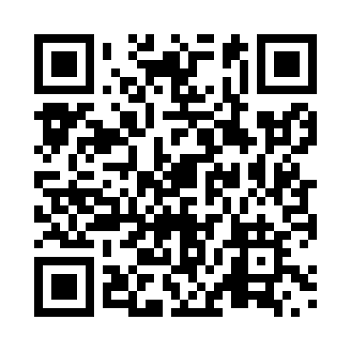
Prayer times for Vilna, Alberta, Canada
Wed 1 May 2024 - Fri 31 May 2024
High Latitude Method: Angle Based Rule
Prayer Calculation Method: Islamic Society of North America
Asar Calculation Method: Hanafi

Date | Day | Fajr | Sunrise | Dhuhr | Asr | Maghrib | Isha
1 | Wed | 3:38 | 5:49 | 1:25 | 6:35 | 9:01 | 11:13
2 | Thu | 3:36 | 5:47 | 1:25 | 6:36 | 9:03 | 11:14
3 | Fri | 3:35 | 5:45 | 1:24 | 6:38 | 9:05 | 11:15
4 | Sat | 3:34 | 5:43 | 1:24 | 6:39 | 9:07 | 11:16
5 | Sun | 3:33 | 5:41 | 1:24 | 6:40 | 9:08 | 11:17
6 | Mon | 3:32 | 5:39 | 1:24 | 6:41 | 9:10 | 11:17
7 | Tue | 3:31 | 5:37 | 1:24 | 6:42 | 9:12 | 11:18
8 | Wed | 3:30 | 5:35 | 1:24 | 6:43 | 9:14 | 11:19
9 | Thu | 3:29 | 5:34 | 1:24 | 6:44 | 9:16 | 11:20
10 | Fri | 3:28 | 5:32 | 1:24 | 6:45 | 9:17 | 11:21
11 | Sat | 3:27 | 5:30 | 1:24 | 6:46 | 9:19 | 11:22
12 | Sun | 3:26 | 5:28 | 1:24 | 6:47 | 9:21 | 11:23
13 | Mon | 3:25 | 5:26 | 1:24 | 6:48 | 9:23 | 11:24
14 | Tue | 3:25 | 5:25 | 1:24 | 6:49 | 9:24 | 11:24
15 | Wed | 3:24 | 5:23 | 1:24 | 6:50 | 9:26 | 11:25
16 | Thu | 3:23 | 5:21 | 1:24 | 6:51 | 9:28 | 11:26
17 | Fri | 3:22 | 5:20 | 1:24 | 6:52 | 9:29 | 11:27
18 | Sat | 3:21 | 5:18 | 1:24 | 6:53 | 9:31 | 11:28
19 | Sun | 3:21 | 5:17 | 1:24 | 6:54 | 9:32 | 11:29
20 | Mon | 3:20 | 5:15 | 1:24 | 6:55 | 9:34 | 11:29
21 | Tue | 3:19 | 5:14 | 1:24 | 6:56 | 9:36 | 11:30
22 | Wed | 3:19 | 5:12 | 1:24 | 6:57 | 9:37 | 11:31
23 | Thu | 3:18 | 5:11 | 1:25 | 6:57 | 9:39 | 11:32
24 | Fri | 3:17 | 5:10 | 1:25 | 6:58 | 9:40 | 11:33
25 | Sat | 3:17 | 5:09 | 1:25 | 6:59 | 9:42 | 11:33
26 | Sun | 3:16 | 5:07 | 1:25 | 7:00 | 9:43 | 11:34
27 | Mon | 3:16 | 5:06 | 1:25 | 7:01 | 9:44 | 11:35
28 | Tue | 3:15 | 5:05 | 1:25 | 7:02 | 9:46 | 11:36
29 | Wed | 3:15 | 5:04 | 1:25 | 7:02 | 9:47 | 11:36
30 | Thu | 3:14 | 5:03 | 1:25 | 7:03 | 9:48 | 11:37
31 | Fri | 3:14 | 5:02 | 1:26 | 7:04 | 9:50 | 11:38
Prayer times provided by https://www.salahtimes.com

