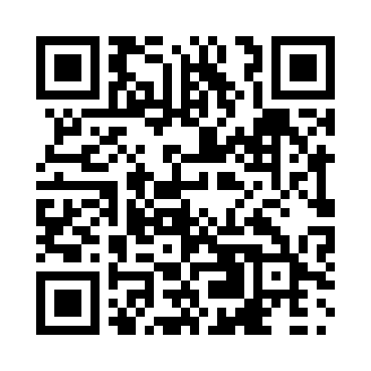
Prayer times for Bow Island, Alberta, Canada
Wed 1 May 2024 - Fri 31 May 2024
High Latitude Method: Angle Based Rule
Prayer Calculation Method: Islamic Society of North America
Asar Calculation Method: Hanafi

Date | Day | Fajr | Sunrise | Dhuhr | Asr | Maghrib | Isha
1 | Wed | 4:11 | 6:01 | 1:23 | 6:28 | 8:45 | 10:35
2 | Thu | 4:09 | 5:59 | 1:22 | 6:29 | 8:46 | 10:38
3 | Fri | 4:06 | 5:58 | 1:22 | 6:30 | 8:48 | 10:40
4 | Sat | 4:03 | 5:56 | 1:22 | 6:31 | 8:49 | 10:42
5 | Sun | 4:01 | 5:54 | 1:22 | 6:32 | 8:51 | 10:45
6 | Mon | 3:58 | 5:53 | 1:22 | 6:33 | 8:52 | 10:47
7 | Tue | 3:56 | 5:51 | 1:22 | 6:34 | 8:54 | 10:50
8 | Wed | 3:53 | 5:49 | 1:22 | 6:35 | 8:55 | 10:52
9 | Thu | 3:51 | 5:48 | 1:22 | 6:36 | 8:57 | 10:55
10 | Fri | 3:48 | 5:46 | 1:22 | 6:36 | 8:58 | 10:57
11 | Sat | 3:46 | 5:45 | 1:22 | 6:37 | 9:00 | 11:00
12 | Sun | 3:43 | 5:43 | 1:22 | 6:38 | 9:01 | 11:02
13 | Mon | 3:41 | 5:42 | 1:22 | 6:39 | 9:03 | 11:04
14 | Tue | 3:38 | 5:40 | 1:22 | 6:40 | 9:04 | 11:07
15 | Wed | 3:36 | 5:39 | 1:22 | 6:41 | 9:05 | 11:09
16 | Thu | 3:33 | 5:38 | 1:22 | 6:41 | 9:07 | 11:12
17 | Fri | 3:31 | 5:36 | 1:22 | 6:42 | 9:08 | 11:14
18 | Sat | 3:29 | 5:35 | 1:22 | 6:43 | 9:09 | 11:16
19 | Sun | 3:28 | 5:34 | 1:22 | 6:44 | 9:11 | 11:17
20 | Mon | 3:28 | 5:33 | 1:22 | 6:45 | 9:12 | 11:17
21 | Tue | 3:27 | 5:32 | 1:22 | 6:45 | 9:13 | 11:18
22 | Wed | 3:27 | 5:30 | 1:22 | 6:46 | 9:15 | 11:19
23 | Thu | 3:26 | 5:29 | 1:22 | 6:47 | 9:16 | 11:19
24 | Fri | 3:26 | 5:28 | 1:22 | 6:48 | 9:17 | 11:20
25 | Sat | 3:25 | 5:27 | 1:23 | 6:48 | 9:18 | 11:21
26 | Sun | 3:25 | 5:26 | 1:23 | 6:49 | 9:20 | 11:21
27 | Mon | 3:24 | 5:25 | 1:23 | 6:50 | 9:21 | 11:22
28 | Tue | 3:24 | 5:25 | 1:23 | 6:50 | 9:22 | 11:22
29 | Wed | 3:24 | 5:24 | 1:23 | 6:51 | 9:23 | 11:23
30 | Thu | 3:23 | 5:23 | 1:23 | 6:52 | 9:24 | 11:24
31 | Fri | 3:23 | 5:22 | 1:23 | 6:52 | 9:25 | 11:24
Prayer times provided by https://www.salahtimes.com

