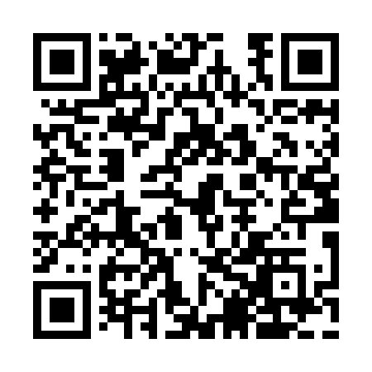
Prayer times for Bear Trap Landing, Maine, USA
Wed 1 May 2024 - Fri 31 May 2024
High Latitude Method: Angle Based Rule
Prayer Calculation Method: Islamic Society of North America
Asar Calculation Method: Shafi

Date | Day | Fajr | Sunrise | Dhuhr | Asr | Maghrib | Isha
1 | Wed | 3:44 | 5:19 | 12:28 | 4:25 | 7:38 | 9:13
2 | Thu | 3:42 | 5:18 | 12:28 | 4:25 | 7:39 | 9:15
3 | Fri | 3:40 | 5:16 | 12:28 | 4:26 | 7:41 | 9:17
4 | Sat | 3:38 | 5:15 | 12:28 | 4:26 | 7:42 | 9:19
5 | Sun | 3:36 | 5:13 | 12:28 | 4:27 | 7:43 | 9:20
6 | Mon | 3:34 | 5:12 | 12:28 | 4:27 | 7:44 | 9:22
7 | Tue | 3:32 | 5:11 | 12:28 | 4:27 | 7:45 | 9:24
8 | Wed | 3:30 | 5:09 | 12:28 | 4:28 | 7:47 | 9:26
9 | Thu | 3:29 | 5:08 | 12:28 | 4:28 | 7:48 | 9:28
10 | Fri | 3:27 | 5:07 | 12:28 | 4:29 | 7:49 | 9:29
11 | Sat | 3:25 | 5:05 | 12:28 | 4:29 | 7:50 | 9:31
12 | Sun | 3:23 | 5:04 | 12:28 | 4:30 | 7:51 | 9:33
13 | Mon | 3:21 | 5:03 | 12:28 | 4:30 | 7:53 | 9:35
14 | Tue | 3:20 | 5:02 | 12:28 | 4:30 | 7:54 | 9:37
15 | Wed | 3:18 | 5:01 | 12:28 | 4:31 | 7:55 | 9:38
16 | Thu | 3:16 | 5:00 | 12:28 | 4:31 | 7:56 | 9:40
17 | Fri | 3:14 | 4:59 | 12:28 | 4:32 | 7:57 | 9:42
18 | Sat | 3:13 | 4:58 | 12:28 | 4:32 | 7:58 | 9:43
19 | Sun | 3:11 | 4:57 | 12:28 | 4:32 | 7:59 | 9:45
20 | Mon | 3:10 | 4:56 | 12:28 | 4:33 | 8:01 | 9:47
21 | Tue | 3:08 | 4:55 | 12:28 | 4:33 | 8:02 | 9:49
22 | Wed | 3:07 | 4:54 | 12:28 | 4:33 | 8:03 | 9:50
23 | Thu | 3:05 | 4:53 | 12:28 | 4:34 | 8:04 | 9:52
24 | Fri | 3:04 | 4:52 | 12:28 | 4:34 | 8:05 | 9:53
25 | Sat | 3:02 | 4:51 | 12:28 | 4:35 | 8:06 | 9:55
26 | Sun | 3:01 | 4:50 | 12:28 | 4:35 | 8:07 | 9:57
27 | Mon | 3:00 | 4:50 | 12:28 | 4:35 | 8:08 | 9:58
28 | Tue | 2:58 | 4:49 | 12:29 | 4:36 | 8:09 | 10:00
29 | Wed | 2:57 | 4:48 | 12:29 | 4:36 | 8:09 | 10:01
30 | Thu | 2:56 | 4:48 | 12:29 | 4:36 | 8:10 | 10:02
31 | Fri | 2:55 | 4:47 | 12:29 | 4:37 | 8:11 | 10:04
Prayer times provided by https://www.salahtimes.com

